Year 4 English Home Learning wc Monday 14th January 2019 – due 21st January 2019
Write a short story about the following image. Try to include a number of simple, compound and complex sentences.
I like to imagine that it is a really small dragon which you can keep in your pocket but when you need to it can grow huge so that you can ride it.
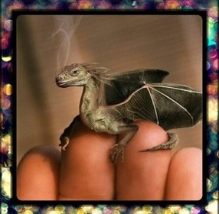
Questions to think about before you write:
- Where is it from?
- Why is it so small?
- Are there more like him?
- Where does he live?
- How will you look after it?
- Will you keep it a secret?
- What is it called?
- Is it magic?
- What magic can it do?

Tiny Dragon
_____________________________________________________________________________________________________________________________________________________________________________________________________________________________________________________________________________________________________________________________________________________________________________________________________________________________________________________________________________________________________________________________________________________________________________________________________________________________________________________________________________________________________________________________________________________________________________________________________________________________________________________________________________________________________________________________________________________________________________________________________________________________________________________________________________________________________________________________________________________________________________________________________________________________________________________________________________________________________________________________________________________________________________________________________________________________________________________________________________________________________________________________________________________________________________________________________________________________________________________________________________________________________________________________________________________________________________________________________________________________________________

Self edit: ______________________________________________________________
Peer edit:_____________________________________________________________________

