




Haytor View Community Primary School & Nursery
Learning together - enjoying success - aiming high - celebrating difference – enriching community
Year 2 Transition Newsletter Summer 2022

Moving On . . .
Transition is the experience children have when they move to a new setting, this might be a new school or a new class. Transition is an important learning experience as it’s the ongoing process of change, therefore we recognise the importance of careful planning for children’s transition experience.

We know the experiences children have at key transition points can offer an opportunity for each child to develop positive learning dispositions regarding ‘change’. These can support the development of children’s emotional and social well-being, and sense of identity. Children who develop positive attributes such as strength, resilience, independence and self-confidence will be able to call on these attributes to support transitions throughout their lives.

Transition at Haytor View is focussed upon building strong and trusting relationships between children, adults and parents/carers, through effective communication, as well as supporting the consistent transfer of existing relationships and relevant information.
“Your commitment to ensuring that all pupils are afforded the very best opportunity to achieve as well as they possibly can, is at the centre of every decision you make.” Ofsted 2017
At Haytor View we support transition through a range of opportunities both across the year and as the children get closer to ‘moving on’:
- Spending time in different spaces around the school;
- Meeting a range of school adults in day to day opportunities such as assembly;
- Having conversations and interactions with different children and adults;
- Having regular discussions throughout the year focused on children’s well-being, learning and development;
- Informal opportunities to meet different people;
- Teachers share each child’s unique motivations, strengths, attitudes, skills, knowledge, understanding and learning dispositions, as children move classes;
- We think about the support each child requires in new situations;
- Individual pupil planning for children with SEND;
- An opportunity for parents/carers to ‘drop in’ and have a chat with your child’s Learning Leader for next year (20th July 3.30pm – 5pm).

In the transition process we ensure children have a voice, providing them with the opportunity to ask questions, seek explanations and express their views. Children who will be in Years 1 to 6 will have a whole class ‘taster’ session on 8th July. Where children will benefit from multiple ‘taster’ opportunities, these will be provided on an individual basis. Arrangements for Foundation Stage children will be facilitated by Miss Butler through individual arrangements.

The ‘taster’ session/s facilitated by your child’s Learning Leader will provide a valuable opportunity to develop their relationships with new children and adults.

Our aim is to ensure that your child has a smooth transition which will enable your child to continue their learning and development in a supported and uninterrupted way. We will keep you in the picture about transition plans via the newsletter, but should you have any queries regarding transition please feel free to discuss them with your child’s current or future teacher, their phase leader, Mr Hampton and Mrs Galling.

Best wishes for a successful transition.
Staffing Changes for 2022 – 23…
When we return to school after the Summer half term break, we always have transition firmly in our minds. The arrangements for Summer 2022 will see children leaving us, others arriving, as well as children moving year groups.

We are pleased and proud that we continue to see our school grow, which is seeing us retain our 8 classes at a time when many schools are having to restrict numbers of classes, but increase numbers of children within them. There are however a number of staff changes to share with you, all of which will take place over the summer break.
“If a pupil is not making enough progress, the reasons for this are unpicked and action is taken swiftly to address “them.
Ofsted 2017

We also say ‘farewell’ to Miss Ansett in the Foundation Stage, as she prepares to return home to Australia. We thank Miss Ansett for the enthusiasm and joy she has brought to the Foundation Stage and wish her well for the future.

We ‘welcome’ Miss Manley and Mrs Brown to the long-term school team - both were successfully recruited into permanent teaching posts at the school prior to the half term break.

New to the Foundation Stage team will be Miss Sloggett who is joining us as a full time teacher as Mrs Penn reduces her hours. Mrs Penn will be providing release cover across the Foundation Stage and Miss Sloggett will be working alongside Miss Butler as the partner class teacher.

Also joining the Foundation Stage team is Mrs Lewis who will be joining us as a Foundation Stage Practitioner. We are delighted to welcome both Miss Sloggett and Mrs Lewis to Haytor View and know you will make them feel welcome.

There are two further appointments we are looking to make in the forthcoming weeks:
- An additional Foundation Stage Practitioner to join our Foundation Stage team;
- A Learning Partner to join Years 5 and 6 team

Further development of our existing staff team see Mrs Cousins taking on a new role of Year 3 and 4 Phase Leader, leading on the development of provision in Years 3 and 4. Miss Shopland will be extending her role next year following her successful appointment into the position of school SENDCo. This will see Miss Shopland developing and overseeing the provision in Foundation Stage, Key Stage 1 and Key Stage 2 for children with SEND.

This Transition Newsletter…
The arrangements put in place to support the transition are as a result of leaders and teachers thinking about each of the children in each of our classes, to ensure they receive opportunities which will support them in effectively ‘transitioning’ from their current class into their new class.

This transition newsletter provides specific details about the transition arrangements for your child, as well as information about the adults your child will be spending time with so you know the main points of contact.

Children will be spending time in their new classes for the first learning session of the day on Friday 8th July. We will also be hosting an after-school opportunity for you to catch up with your child’s current teacher, visit your child’s new class and where possible meet their new teacher - this will take place on Wednesday 20th July 3.30 – 5pm

Organisation for 2022 - 23
Foundation Stage
- Miss Butler – Foundation Stage Leader
- Miss Sloggett – Foundation Stage Learning Leader
- Mrs Penn – Foundation Stage Learning Leader (non-class based)
- Mrs Breakwell – Foundation Stage Practitioner
“Teachers adapt their planning if necessary to ensure that pupils’ learning continues to move forwards at a good rate.”
Ofsted 2017
- Miss Lofthouse – Foundation Stage Practitioner
- Mrs Lewis – Foundation Stage Practitioner

Key Stage 1
- Mr Franklin – Key Stage 1 Leader & Year 2 Learning Leader
- Miss Hall – Year 1 Learning Leader
- Miss Cameron – Learning Leader (non-class based)
- Mrs Finnemore – Learning Partner
- Miss Wicks – Learning Partner
- Mrs Louise will be spending some time supporting Years 1 and 2

Key Stage 2 – Years 3 and 4
- Mrs Cousins – Year 3 and 4 Phase Leader and Year 3 Learning Leader
- Mrs Brown – Year 4 Learning Leader
- Mrs Russell – Learning Leader (not class based)
- Mrs Coleman – Years 3 and 4 Learning Partner
- Mr Whitty – Year 3 and 4 Learning Partner

Key Stage 2 – Years 5 and 6
- Mr Hankin – Years 5 & Year 6 Phase Leader and Year 6 Learning Leader
- Miss Manley – Year 5 Learning Leader
- Mrs Hodgson - Years 5 and 6 Learning Partner
- Mrs Louise will be spending some time supporting Years 5 and 6

Administrative Support
- Mrs Brown – Business Manager and Lead for Administrative Team
- Mrs Irving – Administrative Support and Lead for Attendance
- Mrs Webb – Administrative Support

Information About Your Child’s New Teacher in Year 2 – Mr Franklin

My name is Iain Franklin and I have been at the school for many years now ( I think it might be time to change my portrait as the beard is a bit bigger and a lot more grey!)
I live in Teignmouth with my wife, Jacquie and son, Aidan, although he will soon be leaving home to go to University to study Physics. My family is the most important thing in the world to me, with the children and adults in our community at Haytor View a close second!
I am still here because I am still learning something new everyday. I try my best to give the children time and space to be themselves and show me who they are and what they can do rather than just get them to do what I think they should be doing. This means no two year 2 classes are ever the same.
I am doing this job because I want your children to be happy, not just right now in the moment, but also in the future, at secondary school and beyond into their adult lives by developing real confidence in knowing who and what they are, not just learning to do the things expected of them in the curriculum.
I will always try my best to listen hard to whatever anyone is telling me, even if it makes me feel uncomfortable as this is the only way I can keep learning myself and doing better in the future.
Please keep talking to me about what both you and your child need from me and I will do my best to make it happen.

Miss Cameron will also be supporting your child’s learning during the week
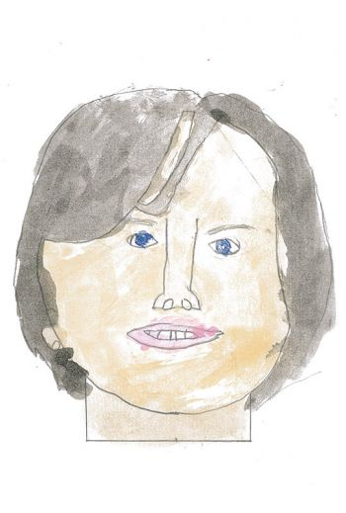
My name is Viki Cameron and I am a KS1 and 2 Learning Leader, I have been a member of the teaching team at Haytor View for over eighteen years. During the next academic year I am looking forward to inspiring learning within KS1. As part of my role I have the amazing opportunity to work with different children within KS1, teaching a variety of subjects including music. I am looking forward to providing a wide range of learning opportunities that focus upon individual needs and supports confidence, love for learning and achievement.
I enjoy living in Kingsteignton with my son Iwan. When I’m not in school I love to spend time with my family going for walks, visiting parks or beaches with our dog. I also enjoy knitting, reading, playing games and having fun with Iwan.

The Opportunities Your Child will Receive During the Year
Year 2 is a great year! Your child will be working with myself, Mrs Bunce and Miss Cameron, learning through a wide range of experiences and opportunties that we anticipate will engage and interest them. For us, year 2 is all about learning how to make those great choices that bring us great success. It might be choices around how we interact with others to develop and create positive supportive relationships right down to what graphemes we choose to use to spell a word so others can read it. Year 2 is when we realise that maths is actually pretty easy because we know we know the basics of place value and number bonds! Year 2 is when we feel able to have more and more control over our thoughts and feelings and so, our own choices. By the end of year 2, children at Haytor View know they are all Amazing Human Beings, who can use their power to choose to achieve whatever they set out to, because they know and understand that they can do anything, if… Our job is to give each child what they need when they tell us what those ifs are so each and every one achieves their fullest potential.
“What is clear is that in every year group teaching responds to pupils’ individual needs.”
Ofsted 2017

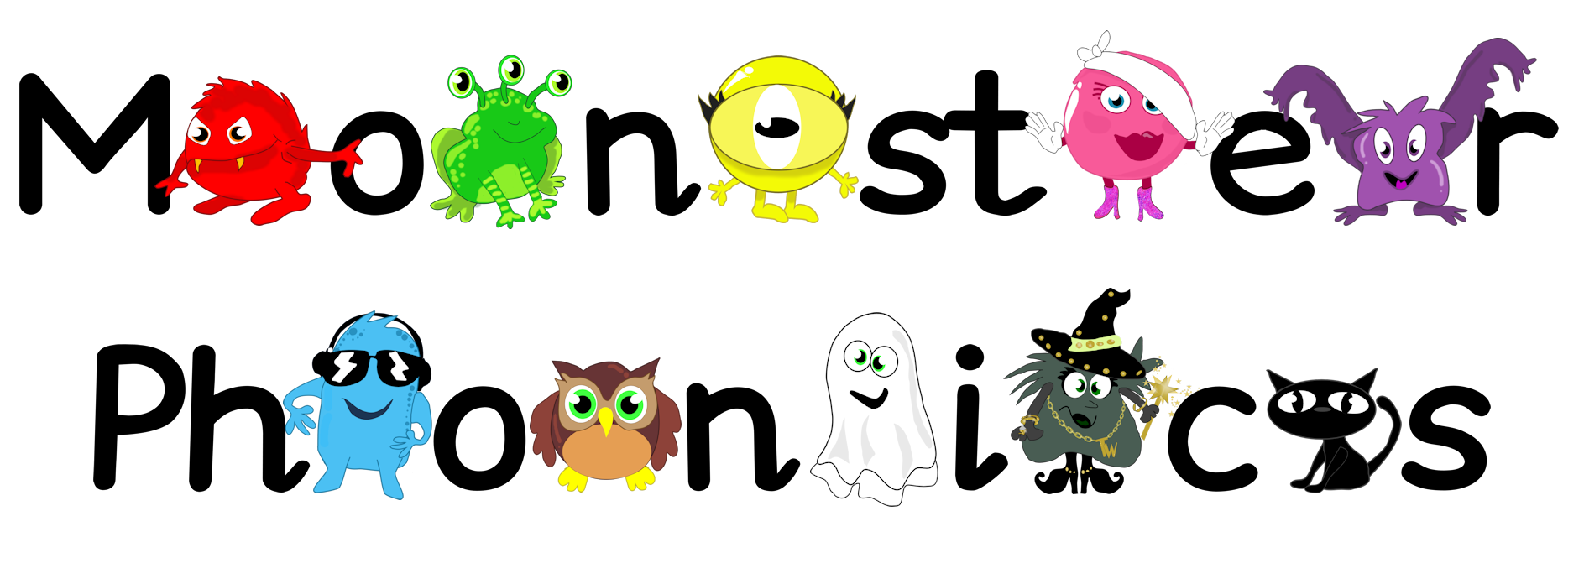
This year we are really looking forward to getting into Monster Phonics and developing Reading across the school. You will have a really important part to play in that process, as reading at home is a key element of lifelong learning success so I look forward to working alongside you to give your child the best possible support in their reading at home.

Key Dates for Your Diary
Autumn Term 2022
- 5th September - Non Pupil Day
- 6th September - First day of term for children
- 20th and 21st October - Non Pupil Days
“Your emphasis on developing pupils’ resilience, their social skills and personal confidence ensures they work hard in lessons and enjoy their time in school.”
Ofsted July 2017
- 24th – 28th October inclusive - Half Term
- 16th December - Last day of Autumn Term

Spring Term 2023
- 3rd January - First day of term for children
- 10th February - Non Pupil Day
- 13th – 17th February inclusive - Half Term
- 31st March - Last day of Spring Term

Summer Term 2023
- 17th April - First day of term for children
- 1st May - Bank Holiday
- 29th May – 2nd June inclusive - Half Term
- 5th June - Non-Pupil Day
- 25th July - Last day of Summer Term

