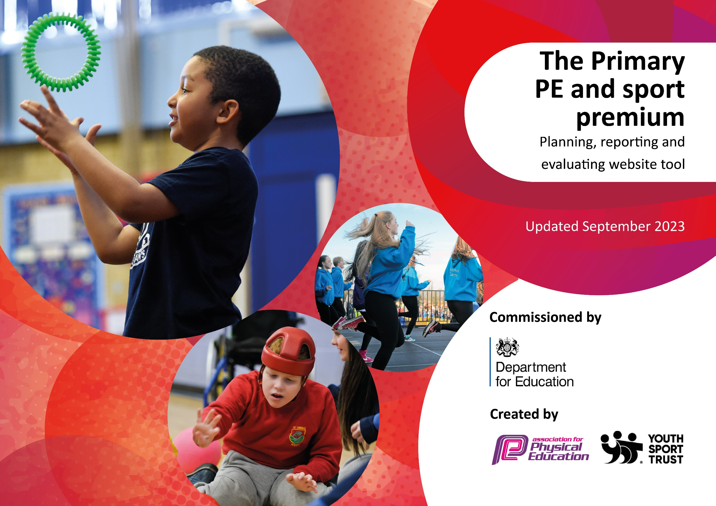

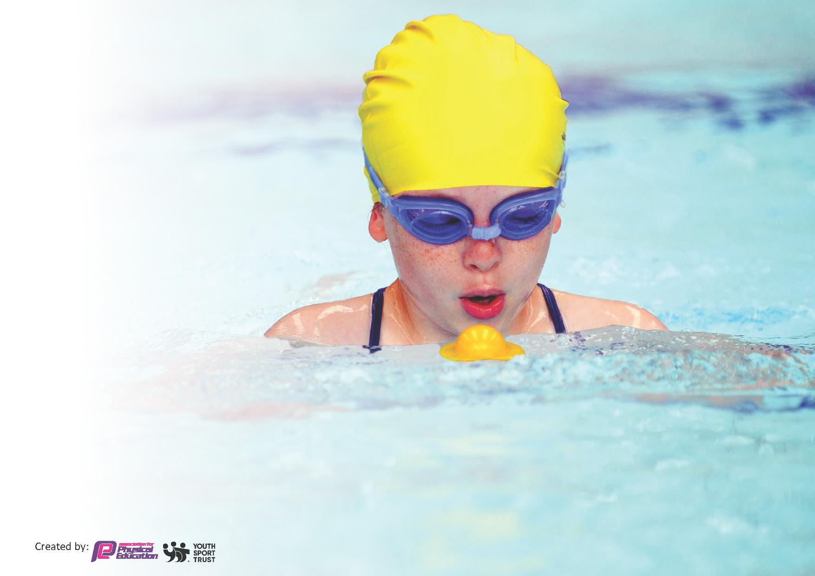
This template can be used for multiple purposes:
by:
- It enables schools to effectively plan their use of the Primary PE and sport premium
- It helps schools to meet the requirements (as set out in guidance) to publish information on their Primary PE and sport premium
- It will be an effective document to support Ofsted inspections enabling schools to evidence progress in Physical Education (PE) and evidence swimming attainment, which forms part of the PE National Curriculum. We would recommend schools consider
the Intent, Implementation and Impact of any spend, as examined within the Education Inspection Framework.

It is important that your grant is used effectively and based on school need.

Schools must use the funding to make additional and sustainable
improvements to the quality of the PE, School Sport and Physical Activity (PESSPA)
they offer. This means that you should use the Primary PE and sport premium to:

- Build capacity and capability within the school to ensure that improvements made now will benefit pupils joining the school in future years
- Develop or add to the PESSPA activities that your school already offers.

The Primary PE and sport premium should not be used to fund capital spend projects; the school’s core budget should fund these. Further detail on capital expenditure can be found in the updated Primary PE and sport premium guidance.

The Primary PE and sport premium guidance, outlines 5 key priorities that funding should be used towards. It is not
necessary that spending has to meet all the key priorities, you should select the priorities that you aim to use any funding towards.

Although completing this template is not a requirement for schools, schools are required to publish details of how they spend this funding. Schools must also outline what the impact this funding has had on pupils’ PE and sport participation and attainment and how any spending will be sustainable in the future. All funding must be spent by 31st July 2024.

The Department for Education has worked closely with the Association for Physical Education (afPE) and the Youth Sport Trust (YST) to develop this template and encourages schools to use it. This template is an effective way of meeting the reporting requirements of the Primary PE and sport premium.
Review of last year’s spend and key achievements (2022/2023)

We recommend you start by reflecting on the impact of current provision and reviewing your previous spend.

Activity/Action | Impact | Comments
To increase children’s participation and engagement in activities during lunch and break times.  Understand the importance of keeping active during lunch and break times.  Story telling dance workshop led by West End in Schools. Children are able to experience dance from other cultures.  SEN children are supported through forest school, gardening and engaging in physical activity by  Children to have access to quality equipment to support their learning and development of physical activity and sports. Maintenance of equipment.  Children are provided with spare PE kit so all children can access PE wearing suitable clothing and footwear.  Identify sport specific needs for CPD among learning leaders, learning partners and governors.  Request/book courses.  Resources are available to support Learning Leaders in planning PE.  Staff develop CPD alongside Running Deer, alternative provision specialist, focusing on ways to improve physical activity through taking learning outside.  Running Deer, alternative provider, work alongside identified parents to enable them to develop approaches to managing and supporting positive behaviours at home, making links to experiences underway in school. | Building upon the CPD the MTA and children received last year, both adults and children work collaboratively to continue to embed an active playtime provision.  Kelsey Brown worked with Lunchtime Leaders and Young Playleaders to continue to provide active playtime provision.  Building children’s experience of sport in a range of cultures  Children are able to participate in culturally diverse activities. These activities offer cross-curricular links and support children in understanding a broad range of activities.  SEN children have received specialist support in engaging with outdoor learning.  Children are able to access key fundamental skills within different sports and develop their skills of the sport through having equipment accessible and enough.  Learning Leaders and Learning Partners have engaged in Impact Days, one every half term.  Each class have engaged in these days, taught by Kelsey Brown. Learning Leaders reflect on their practice and choose an area of development that will support all children in accessing the PE curriculum successfully.  DSSP offer staff training sessions at the beginning of each term. These follow the sports that we learn in our curriculum.  Learning Leaders and Learning Partners develop their practice  SEN children have been provided with targeted support.  Identified children supported through engagement of and links made with parents | Our Young Playleaders have weekly, dedicated time with the school’s PE subject leader to support the development of playtime provision. This sees the playleaders discuss, develop and resource new activities. The playleaders also choose children whom have been strog role models (playtime ambassadors) and these children are celebrated on the school’s weekly newsletter and in the school’s weekly celebration assembly. These arrangements will continue next year led by the member of the school leadership team responsible for lunchtime provision.

Key priorities and Planning
This planning template will allow schools to accurately plan their spending.

Action – what are you planning to do | Who does this action impact? | Key indicator to meet | Impacts and how sustainability will be achieved? | Cost linked to the action
Purchasing playground equipment to support specific children’s engagement in playtime activities.  Purchasing new Playleader bibs  Purchasing new lunchtime equipment  Bespoke training from the South Dartmoor School Sport Partnership.  To encourage children to participate in at least 30 minutes of exercise, a broader range of activities to be available during break and lunch times.  Story telling dance workshop led by West End in Schools. Children are able to experience dance from other cultures.  West end in School story telling working shop for World Book Day  SEN children are supported through forest school, gardening and engaging in physical activity by. | Lunchtime supervisors / teaching staff, coaches - as they need to lead the activity  pupils – as they will take part.  Year 5 and 6 playleaders  All children  SSP  All staff  Young Playleaders in years 5 and 6  Lunchtime staff  All children in the school from F1- year 6  All children  SEN children | Key indicator 1: The engagement of all pupils in regular physical activity – Chief Medical Officers guidelines recommend that primary school pupils undertake at least 30 minutes of physical activity a day in school  Key indicator 1: The engagement of all pupils in regular physical activity – Chief Medical Officers guidelines recommend that primary school pupils undertake at least 30 minutes of physical activity a day in school  Key indicator 1: The engagement of all pupils in regular physical activity – Chief Medical Officers guidelines recommend that primary school pupils undertake at least 30 minutes of physical activity a day in school  Key indicator 1: The engagement of all pupils in regular physical activity – Chief Medical Officers guidelines recommend that primary school pupils undertake at least 30 minutes of physical activity a day in school  Key indicator 3: Increased confidence, knowledge and skills of all staff in teaching PE and sport  Key indicator 1: The engagement of all pupils in regular physical activity – Chief Medical Officers guidelines recommend that primary school pupils undertake at least 30 minutes of physical activity a day in school  Key indicator 3: Increased confidence, knowledge and skills of all staff in teaching PE and sport  Key indicator 1: The engagement of all pupils in regular physical activity – Chief Medical Officers guidelines recommend that primary school pupils undertake at least 30 minutes of physical activity a day in school  Key indicator 4: Broader experience of a range of sports and activities offered to all pupils  Key indicator 1: The engagement of all pupils in regular physical activity – Chief Medical Officers guidelines recommend that primary school pupils undertake at least 30 minutes of physical activity a day in school  Key indicator 4: Broader experience of a range of sports and activities offered to all pupils  Key indicator 1: The engagement of all pupils in regular physical activity – Chief Medical Officers guidelines recommend that primary school pupils undertake at least 30 minutes of physical activity a day in school  Key indicator 4: Broader experience of a range of sports and activities offered to all pupils | To increase children’s participation and engagement in activities during lunch and break times.  Understand the importance of keeping active during lunch and break times.  To support Year 5 and 6 Playleaders in their role on the playground engaging all children in play.  To support engagement in quality play and physical development during KS2 break times and whole school lunchtimes  Building upon the CPD the MTA and children received last year, both adults and children work collaboratively to continue to embed an active playtime provision.  Kelsey Brown (SSP) worked with Lunchtime Leaders and Young Playleaders to continue to provide active playtime provision.  Building children’s experience of sport in a range of cultures  For children to experience dance in different cultures. All children across the school have the opportunity to learn a new dance with links to music and RE.  Children are able to participate in culturally diverse activities. These activities offer cross-curricular links and support children in understanding a broad range of activities  Children are able to explore creative movement and story telling through dance.  Children engage in enhanced levels of physical activities outside the classroom environment.  Children develop their bush craft skills to develop trust, self-belief, self-reliance and resilience.  Children to engage more readily in team activities and sports. | £45.94  £93.96  £45.64  £1,193.90  £960  (DSSP)  £960  £808  £838

PE equipment to be maintained and/or replaced  Running Deer specialist, focusing on ways to improve physical activity through taking learning outside.  To ensure children have access to high quality PE and School Sports by providing:  • Training for Learning Leaders.  • Training for Learning Partners.  • Specialists to teach alongside teachers.  Ongoing CPD for PE Lead.  To ensure children have access to high quality PE and School Sports by providing:  • Training for Learning Leaders.  • Training for Learning Partners.  • Specialists to teach alongside teachers.  Ongoing CPD for PE Lead.  DSSP offer staff training sessions at the beginning of each term. These follow the sports that we learn in our curriculum.  Children in years 2 and 5 are given the opportunity to learn to swim. Additional swimming provision is used to target pupils who are not able to meet the swimming requirements of the National Curriculum.  Lifeguard and water safety visit to KS2  To engage children in a circus skills day led by Lucas Jet Circus.  To offer a wider range of sporting activities that are accessible to all children, including those with SEND.  To attend a wide range of sporting festival accessible through the SSP to children throughout the school.  Children have engaged in intra-school competition. This has allowed them to participate in competitive sports, within their key stages. This has been delivered through the SSP with Handball intra competitions in KS2 and Benchball intra competitions in KS1.  Children across the school have been provided with opportunity to participate in a range of sports led be qualified coaches from Premier Sports. Sporting opportunities are inclusive and rotate on a half termly basis.  Whole school engagement with Karate taster sessions | All children  Teaching assistants  All staff  All staff  Children in year 5 and year 2  Children in KS2  All children  Children in Year 1, Year 3 and Year 4  The sporting events children have participated in through the SSP are:  • Year 1 Sports Festival  • Year 3 Striking and Fielding Festival  • Year 4 Mini Olympic  All children  All children  All children | Key indicator 2: The profile of PESSPA being raised across the school as a tool for whole school improvement  Key indicator 2: The profile of PESSPA being raised across the school as a tool for whole school improvement  Key indicator 3: Increased confidence, knowledge and skills of all staff in teaching PE and sport  Key indicator 3: Increased confidence, knowledge and skills of all staff in teaching PE and sport  Key indicator 3: Increased confidence, knowledge and skills of all staff in teaching PE and sport  Key indicator 4: Broader experience of a range of sports and activities offered to all pupils  Key indicator 2: The profile of PESSPA being raised across the school as a tool for whole school improvement  Key indicator 4: Broader experience of a range of sports and activities offered to all pupils  Key indicator 4: Broader experience of a range of sports and activities offered to all pupils  Key indicator 4: Broader experience of a range of sports and activities offered to all pupils  Key indicator 5: Increased participation in competitive sport  Key indicator 5: Increased participation in competitive sport  Key indicator 5: Increased participation in competitive sport  Key indicator 1: The engagement of all pupils in regular physical activity – Chief Medical Officers guidelines recommend that primary school pupils undertake at least 30 minutes of physical activity a day in school  Key indicator 4: Broader experience of a range of sports and activities offered to all pupils | Children to have access to quality equipment to support their learning and development of physical activity and sports. Maintenance of equipment.  Children are provided with spare PE so all children can access PE wearing suitable clothing and footwear.  Children are able to access key fundamental skills within different sports and develop their skills of the sport through having equipment accessible and enough.  SEN children have been provided with targeted support.  Adults supporting SEN children have been supported in their consideration of outdoor physical learning  Identify sport specific needs for CPD among learning leaders, learning partners and governors.  Request/book courses.  Resources are available to support Learning Leaders in planning PE.  Adults are well supported in the confidence to deliver quality and effective PE teaching.  Learning Leaders and Learning Partners have engaged in Impact Days, one every half term.  Each class have engaged in these days, taught by Kelsey Brown. Learning Leaders and PE lead reflect on their practice and choose an area of development that will support all children in accessing the PE curriculum successfully.  Learning Leaders and Learning Partners develop their practice.  Qualified sports coaches have supported teachers to enhance and extend current swimming opportunities.  Every year children and their families find themselves in dangerous situations that could have been avoided if they had been aware of the most basic safety information. Our assemblies aim to give pupils an understanding of water safety and enable them to identify problems that may occur in, on and around the water. Children in years 2 to 6 attended the assembly:  Children are now able to.  • Identify a Beach Lifeguard  • State the meaning of the Beach flags  • Identify hazards on a beach  • Know what to do if they get into trouble or see someone else in trouble  • Explain key sun safety messages  Children are able to experience a wider variety of physical activity. Children are able to experience professional, aspirational performances. Children’s perceptions of physical exercise and sported supported positively.  Children have begun to engage in more sporting events held by the DSSP. These have taken place at Newton Abbot College alongside other schools in our learning community.  Children are beginning to develop their confidence in more competitive sports and engaging in team activities.  Opportunities to work with adults and children who are not part of the school community. Engagement with potential teachers from secondary school.  Giving the children opportunities to competitive team sport has supported the children’s confident and developed their resilience. The children have been working hard on the social and emotional aspects of competitive sports and managing the feelings that come with this.  Children attending afterschool club have an awareness of a greater range of sports and a more in-depth knowledge of competitive sports for inter competitions within the SSP.  Exercising outside of school promoted. Children across different year groups are able to engage in a range of different sports. Parents are supported in engaging in sports activities outside of school | £150  £808.50  £960  £1000  £500  £800  £960  £615 (transport)  £1200  £4823  £1,212

Key achievements 2023-2024
This template will be completed at the end of the academic year and will showcase the key achievements schools have made with their Primary PE and sport premium spending.

Activity/Action | Impact | Comments
Lifeguard visit to KS2  New playground equipment  Lucas Jet Circus experience – May 2024  West End in Schools – November 2023 – Diwali Dance Workshop  Additional support for swimming through increased levels of professional tuition  Engagement of Running Deer – Outdoor Education Providers | Every year children and their families find themselves in dangerous situations that could have been avoided if they had been aware of the most basic safety information. Our assemblies aim to give pupils an understanding of water safety and enable them to identify problems that may occur in, on and around the water.  New playground equipment has been sourced to provide children with quality playtime provision as an extension of their physical development.  This experience provided whole school engagement in sport. The experiences were both aspirational and inclusive.  Engagement of children in professionally led dance learning linked to story telling and celebration of Diwali  Extended levels of professional instruction as part of our swimming programme that has now been extended to encompass Year 2 as well as Year 5 for the second year in successions.  Bespoke opportunities for key children to access outdoor education in support of their physical and SEMH development. Introduced enhanced levels of physical activity to play. Staff learned alongside specialists. | Children in years 2 to 6 attended the assembly:  Children are now able to.  - Identify a Beach Lifeguard  - State the meaning of the Beach flags  - Identify hazards on a beach  - Know what to do if they get into trouble or see someone else in trouble  - Explain key sun safety messages  New equipment is due to be introduced in Autumn 2024  Our links with this organization continue based upon quality of previous experiences and impact upon children’s learning and teacher development.  We look forward to seeing the impact of extending the swimming programme when our current Year 5 children become the first to experience two periods of swimming instruction and experience when they attend in Summer 2025.  Strong relationship built with provider – may well access for future support and development.

Swimming Data
Meeting National Curriculum requirements for swimming and water safety.
Priority should always be given to ensuring that pupils can perform safe self-rescue even if they do not fully meet the first two requirements of the National Curriculum programme of study

Question | Stats: | Further context  Relative to local challenges
What percentage of your current Year 6 cohort can swim competently, confidently and proficiently over a distance of at least 25 metres? | 9/30  30% | We have introduced swimming lessons in year 2 as well as year 5 to support children’s attainment in swimming.
What percentage of your current Year 6 cohort can use a range of strokes effectively [for example, front crawl, backstroke, and breaststroke]? | 9/30  30% | This data was gathered from the year 6 pupils at the end of year 5. Children are provided with swimming lessons in year 2 and year 5.  There is no swimming data for new starters in year 6.

What percentage of your current Year 6 cohort are able to perform safe self-rescue in different water-based situations? | 30% | As a part of the swimming sessions in year 5, children are taught safe self-rescue.  The school is also visited by the lifeguard where year 2-year 6 are taught water safety at the coast and in the pool.
If your schools swimming data is below national expectation, you can choose to use the Primary PE and sport premium to provide additional top-up sessions for those pupils that did not meet National Curriculum  requirements after the completion of core lessons. Have you done this? | Yes/No | As a school, we have begun to provide swimming lessons in both year 2 and year 5. This began in the year 2023.
Have you provided CPD to improve the knowledge and confidence of staff to be able to teach swimming and water safety? | Yes/No | Swimming teaching is delivered by swimming coaches at Newton Abbot Leisure Centre. Children and adults supervising are directed through basic water safety in the pool. In year 5, children are taught how to manage more challenging situations in the pool, such as diving for objects and basic prevention of drowning.

Signed off by:

Head Teacher: | Scott Hampton
Subject Leader or the individual responsible for the Primary PE and sport premium: | Rebecca Hall, PE Subject Leader
Governor: | Michael Bennie, Curriculum Lead Governor
Date: | 4.9.24.

