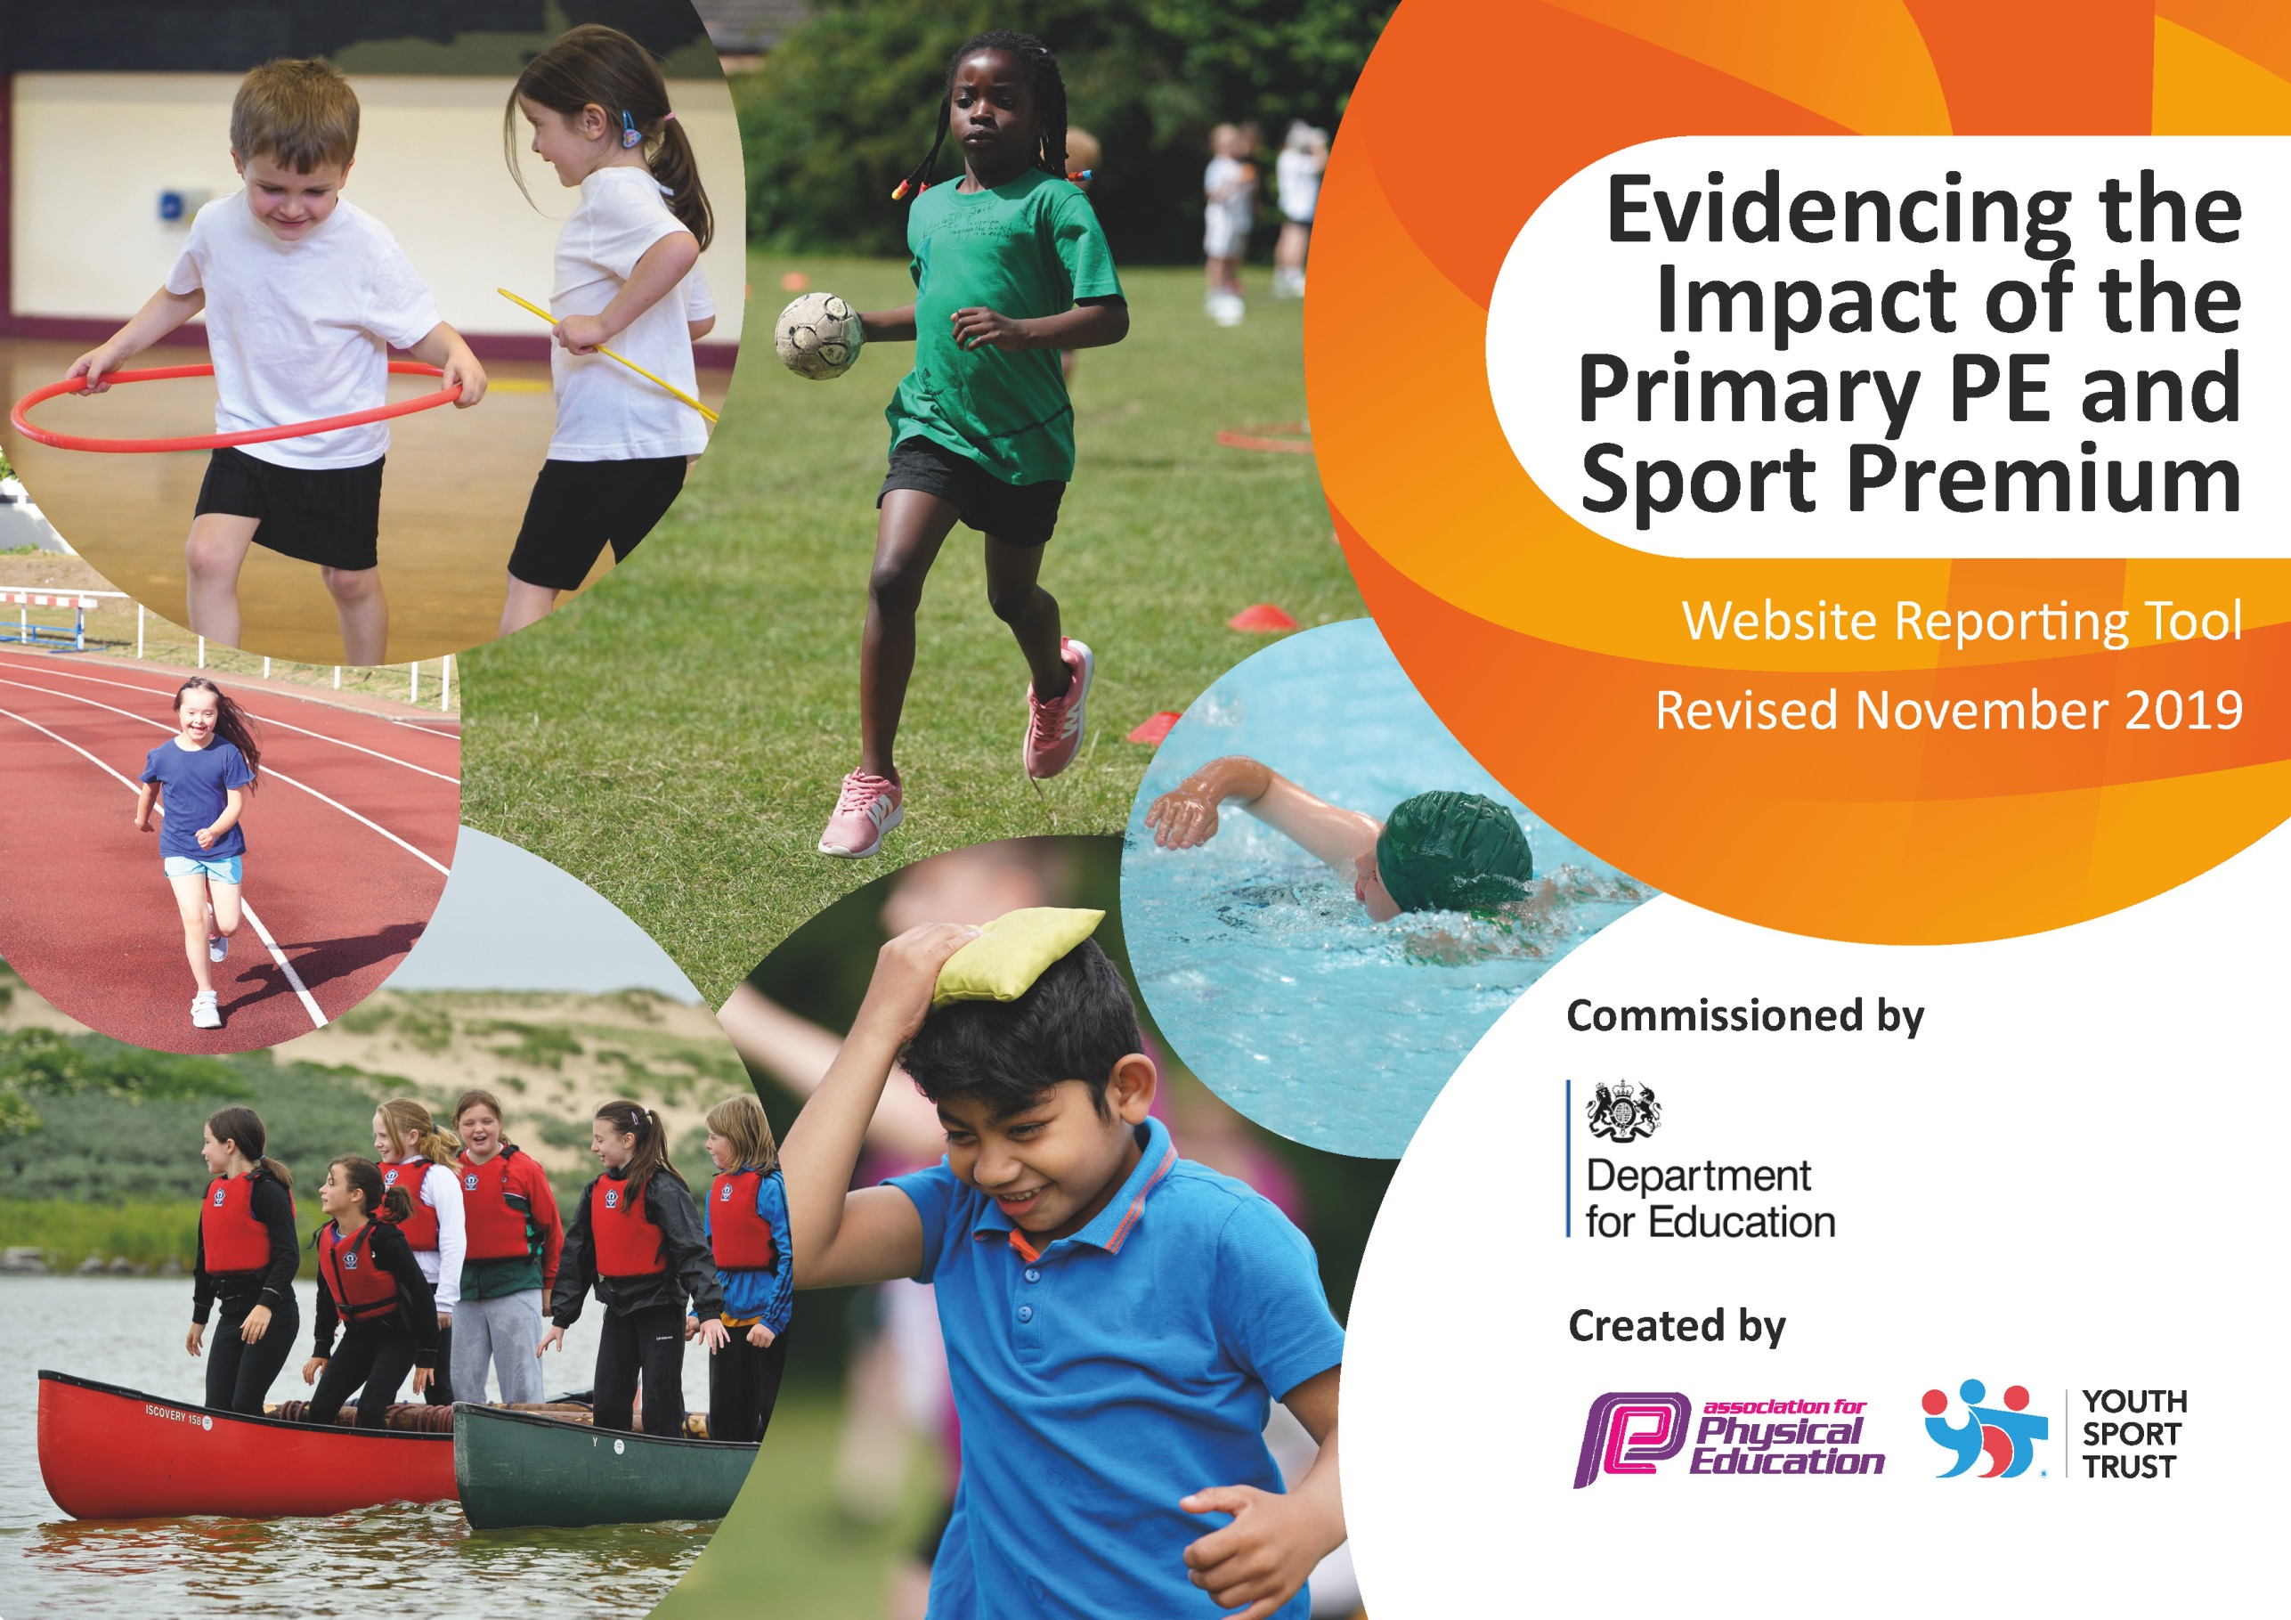
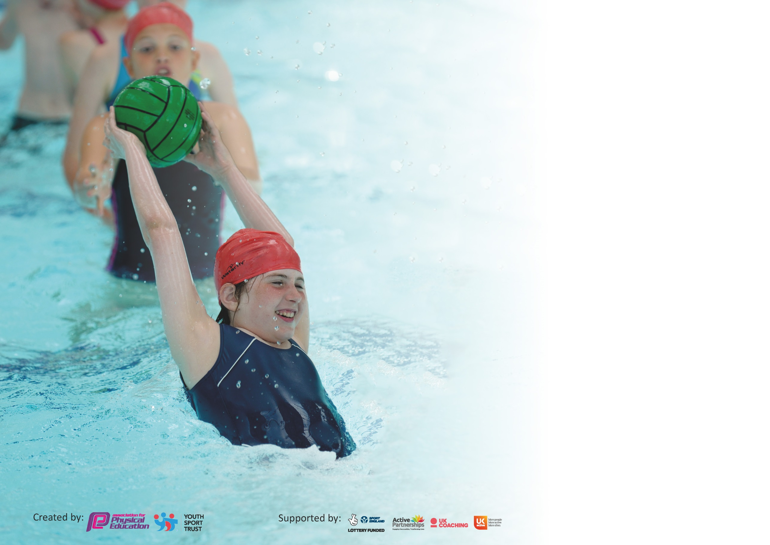

It is important that your grant is used effectively and based on school need. The Education Inspection Framework (Ofsted 2019 p64) makes clear there will be a focus on ‘whether leaders and those responsible for governors all understand their respective roles and perform these in a way that enhances the effectiveness of the school’.

Under the Quality of Education criteria (p41) inspectors consider the extent to which schools can articulate their curriculum (INTENT), construct their curriculum (IMPLEMENTATION) and demonstrate the outcomes which result (IMPACT).

To assist schools with common transferable language this template has been developed to utilise the same three headings which should make your plans easily transferable between working documents.

Schools must use the funding to make additional and sustainable improvements to the quality of Physical Education, School Sport and Physical Activity (PESSPA) they offer. This means that you should
use the Primary PE and Sport Premium to:

- Develop or add to the PESSPA activities that your school already offer
- Build capacity and capability within the school to ensure that improvements made now will benefit pupils joining the school in future years

Please visit gov.uk for the revised DfE guidance including the 5 key indicators across which schools should demonstrate an improvement. This document will help you to review your provision and to report your spend. DfE encourages schools to use this template as an effective way of meeting the reporting requirements of the Primary PE and Sport Premium.

We recommend you start by reflecting on the impact of current provision and reviewing the previous spend.

Schools are required to publish details of how they spend this funding as well as on the impact it has on pupils’ PE and sport participation and attainment by the end of the summer term or by 31st July 2020 at the latest.

We recommend regularly updating the table and publishing it on your website throughout the year. This evidences your ongoing self-evaluation of how you are using the funding to secure maximum, sustainable impact. Final copy must be posted on your website by the end of the academic year and no later than the 31st July 2020. To see an example of how to complete the table please click HERE.

Support for review and reflection - considering the 5 key indicators from DfE, what development needs are a priority for your setting and your pupils now and why? Use the space below to reflect on previous spend and key achievements and areas for development.

Key achievements to date until July 2021: | Areas for further improvement and baseline evidence of need:
- Children in KS1 and KS2 participate in ‘Life Education’ sessions. These sessions develop children’s awareness of their bodies and health. It develops their understanding of drug prevention as well as giving them a wider understanding of how social factors can affect their health.  - All children in year 6 have completed their Level 1 Bikeability. Unfortunately the children were unable to complete Level 2 due to Covid-19  - All children in foundation stage, KS1 and KS2 engaged in a broader range of activities. This included dance recovery workshop, circus skill and Life Education workshops.  - All children in KS2 participated in ‘Spirit of Adventure’ activity days. The children participated in physical, team building activities that also supported their mental wellbeing, resilience, self-esteem and confidence. | - To raise the attainment in swimming through catch up sessions for Year 5 and 6 pupils who missed out on provision due to school closure. To be followed by further focus upon early intervention in year 2. This will provide additional swimming provision targeted to pupils not able to meet the swimming requirements of the national curriculum.  - Year 6 children to complete level 1 and 2 Bike Ability.  - To raise the participation of children attending extra-curriculum sports club in KS2 when COVID-related restrictions have been lifted.  - KS1 to offer a sporting extra-curricular activity after school when these are able to sit within whole school offer following COVID-related restrictions

Meeting national curriculum requirements for swimming and water safety.
What percentage of your current Year 6 cohort swim competently, confidently and proficiently over a distance of at least 25 metres?  N.B. Even though your pupils may swim in another year please report on their attainment on leaving  primary school at the end of the summer term 2021. | 33%
What percentage of your current Year 6 cohort use a range of strokes effectively [for example, front crawl, backstroke and breaststroke]? | 25%
What percentage of your current Year 6 cohort perform safe self-rescue in different water-based situations? | 90%
Schools can choose to use the Primary PE and Sport Premium to provide additional provision for swimming but this must be for activity over and above the national curriculum requirements. Have you used it in this way? | Yes/No  £500 additional support was provided for children to support them to meeting national standards.

Action Plan and Budget Tracking
Capture your intended annual spend against the 5 key indicators. Clarify the success criteria and evidence of impact that you intend to measure to evaluate for pupils today and for the future.

Academic Year: 2020 - 2021 | Total fund allocated: £17,611.00  Underspend carried forward from 2019-2020: £6363.16  Total spend: £23,838.25 | Date Updated: July 2021
Key indicator 1: The engagement of all pupils in regular physical activity – Chief Medical Officer guidelines recommend that primary school pupils undertake at least 30 minutes of physical activity a day in school |  |  |  | Percentage of total allocation:
 |  |  |  | %
Intent | Implementation |  | Impact
Your school focus should be clear what you want the pupils to know and be able to do and about  what they need to learn and to  consolidate through practice: | Make sure your actions to achieve are linked to your intentions: | Funding allocated: | Evidence of impact: what do pupils now know and what can they now do? What has changed?: | Sustainability and suggested next steps:
To increase children’s participation and engagement in activities during lunch and break times.  Children’s social and emotional wellbeing valued and happier due to actively engaging with others on the playground.  Understand the importance of keeping active during lunch and break times.  Opportunities for all children based on CMO guidelines of being active for 30 minutes a day in school. | Equipment purchased to give children a broad range of play opportunities. | £2375.00  (SSP)  £584.28  (lunch and break time equipment)  Total: £2959.28 | Building upon the CPD the MTA and children received last year, both adults and children work collaboratively to continue to embed an active playtime provision.  Due to Covid-19, there was a high importance placed on each bubble having enough equipment for playtimes as the children could no longer share. Having more equipment allowed the children to maintain active playtime.  All Learning Leaders and MTA actively engaging with children on the playground, modelling positive behaviours and demonstrating resilience.  Ian Patchett to work with MTA and Young Playleaders to continue to provide active playtime provision. | Unfortunately due to Covid-19 the children were unable to engage in the Young Play Leaders sessions lead by our SSP. We hope that this will start again in the next academic year.  Ian Patchett to continue to work with MTA and children, in each bubble, to help to support the delivery of an active playtimes that are inclusive to all children.  Learning Leaders and MTA to continue to support active play during break and lunch times. Once COVID restrictions have been lifted, Young Play Leaders after school club will restart which allows the children to plan which activities KS2 will be participating in during break and lunch times.
Key indicator 2: The profile of PESSPA being raised across the school as a tool for whole school improvement |  |  |  | Percentage of total allocation:
 |  |  |  | %
Intent | Implementation |  | Impact
Your school focus should be clear what you want the pupils to know and be able to do and about  what they need to learn and to  consolidate through practice: | Make sure your actions to achieve are linked to your intentions: | Funding allocated: | Evidence of impact: what do pupils now know and what can they now do? What has changed?: | Sustainability and suggested next steps:
To increase children’s participation and engagement in PE lessons and clubs.  - Enough equipment so all children can access PE and are active throughout every session.  - Equipment for each bubble to maximise time in PE lessons.  - Children are able to access the PE equipment without any limitations. | PE Equipment for 3 bubbles (KS1, Lower KS2, Upper KS2):  - Tag Rugby Equipment  - Athletics Equipment  - Cricket Equipment  - Storage  - Netball Equipment  - Dartmoor 3 Ball Equipment  - Dance  - Gymnastic Equipment  - Wobble Boards  - Springboard  - Vault  - Crashmat  - Storage  - PE Equipment Repairs  - Storage Sheds | £13,291.05  Total: £13,291.05 | Due to COVID restrictions the school invested a large amount of the Sports Premium funding in ensuring there is enough equipment available for each bubble.  This has allowed each child to continue to receive high-quality PE provision without compromising access to equipment due to government guidelines. | Equipment to be maintained by each bubble throughout the school. Learning Leaders to let MC know if equipment needs maintenance or replacing.

Key indicator 3: Increased confidence, knowledge and skills of all staff in teaching PE and sport |  |  |  | Percentage of total allocation:
 |  |  |  | %
Intent | Implementation |  | Impact
Your school focus should be clear | Make sure your actions to | Funding | Evidence of impact: what do | Sustainability and suggested
what you want the pupils to know | achieve are linked to your | allocated: | pupils now know and what | next steps:
and be able to do and about | intentions: |  | can they now do? What has
what they need to learn and to |  |  | changed?:
consolidate through practice:
To ensure children have access to high quality PE and School Sports by providing:  - Training for Learning Leaders.  - Training for Learning Partners.  - Specialists to teach alongside teachers.  - Ongoing CPD for PE Lead. | Identify sport specific needs for CPD among learning leaders, learning partners and governors.  Request/book courses.  Resources are available to support Learning Leaders in planning PE.  South Dartmoor SSP Annual Conference. | £2375.00  (SSP)  Total: £2375.00 | Learning Leaders and Learning Partners have engaged in Impact Days, one every half term.  Each class have engaged in these days, taught by Ian Patchett. Learning Leaders reflect on their practise and choose an area of development that will support all children in accessing the PE curriculum successfully.  Learning Leaders and Learning Partners develop their practise.  PE subject lead has attended the Dartmoor SSP annual conference and the SSP PLT meetings. This provides the confidence and knowledge to support other members of staff as required. | Staff to continue to be offered CPD opportunities so they are confidently able to deliver PE.  Learning Leaders and Partners to inform MC of any training requirements they need. MC to contact SSP to provide support.
Key indicator 4: Broader experience of a range of sports and activities offered to all pupils |  |  |  | Percentage of total allocation:
 |  |  |  | %
Intent | Implementation |  | Impact
Your school focus should be clear | Make sure your actions to | Funding | Evidence of impact: what do | Sustainability and suggested
what you want the pupils to know | achieve are linked to your | allocated: | pupils now know and what | next steps:
and be able to do and about | intentions: |  | can they now do? What has
what they need to learn and to |  |  | changed?:
consolidate through practice:
To use specialists to offer a diverse and wide range of activities that are accessible to all children, including SEND. | MC to establish links and relationships with wider organisations that offer children new and a wider range of physical activities outside the curriculum sports.  These have included:  - Spirit of Adventure  - Dance Recovery Workshop  (West End in Schools)  - Lucas Jet Circus  - Life Education | £2990.00  £498.80  £650.00  £710.00  Total: £4848.80 | All KS2 classes participated in an outdoor, physical team building activity days. This supported the children in developing both their mental and physical wellbeing.  All children were able to participate fully and in every activity.  The children were able to experience and learn dances that focused upon current issues.  All children, across the school, were able to engage successfully with the dancing.  Learning leaders were able to gain additional CPD through observing and participating in the workshops.  This is the second year Lucas Jet Circus has offered a great, unique experience to our children. The children practised new skills that many had never done before or had only practised for a short amount of time the previous year. This improved the resilience and perseverance. They also had lots of fun!  All children across the school were able to take part in these sessions and some performed in a show at the end of the day.  Life Education gives children a different experience when learning PHSE. It is taught by professionals to give children a better understanding about their bodies, health issues and social and emotional wellbeing.  The children are able to experience this in an interactive mobile classroom.  Learning leaders also benefit from having access to PHSE lesson plans that correspond to what has been taught and allows for follow-up sessions to take place in class.  Usually Life Education run a parent session which gives parents and carers an awareness about what is being taught and how they can support their children out of school. However, due to COVID this was unable to take place this year. | These days were set up as the children could not participate in residential due to COVID.  Children were able to access a broader range of activities.  Following a review of the quality of experiences, the school will continue to maintain the working relationship with West End in Schools. Children to be able to access different dance workshops to increase their skills and confidence in dance.  Following a review of the quality of experiences, the school will continue to maintain the working relationship with Lucas Jet Circus. All children to continue to access the workshop.  Purchase some of the equipment so children can practice the new skills they have learnt in the workshops.  Following a review of the quality of experiences, the school will continue to maintain the working relationship with Life Education Wessex. All children to continue to access the workshop.

Key indicator 5: Increased participation in competitive sport |  |  |  | Percentage of total allocation:
 |  |  |  | %
Intent | Implementation |  | Impact
Your school focus should be clear | Make sure your actions to | Funding | Evidence of impact: what do | Sustainability and suggested
what you want the pupils to know | achieve are linked to your | allocated: | pupils now know and what | next steps:
and be able to do and about | intentions: |  | can they now do? What has
what they need to learn and to |  |  | changed?:
consolidate through practice:
To offer a wider range of sporting activities that are accessible to all children, including those with SEND. | Children have engaged in intra-school competition. This has allowed them to participate in competitive sports, within their bubbles but with different classes. | None | Giving the children opportunities to competitive team sport has supported the children’s confident and developed their resilience. The children have been working hard on the social and emotional aspects of competitive sports and managing the feelings that come with this.  Unfortunately the children have not been able to access any extra-curricular clubs, competitions or festivals with other primary schools due to COVID. | More intra-school competitions to be held in both KS1 and KS2. MC to offer advice, support and resources for Learning Leaders. Ian Patchett to teach intra-competitions to year groups to support the delivery of the competitions.  When COVID restrictions are lifted, children are encouraged to and will have more opportunities to access competitions through the SSP both in KS1 and KS2.

Signed off by
Head Teacher: | Kate Galling
Date: | 12-11-21
Subject Leader: | Michaela Cousins
Date: | July 2021
Governor: | FGB
Date: | 12-11-21

