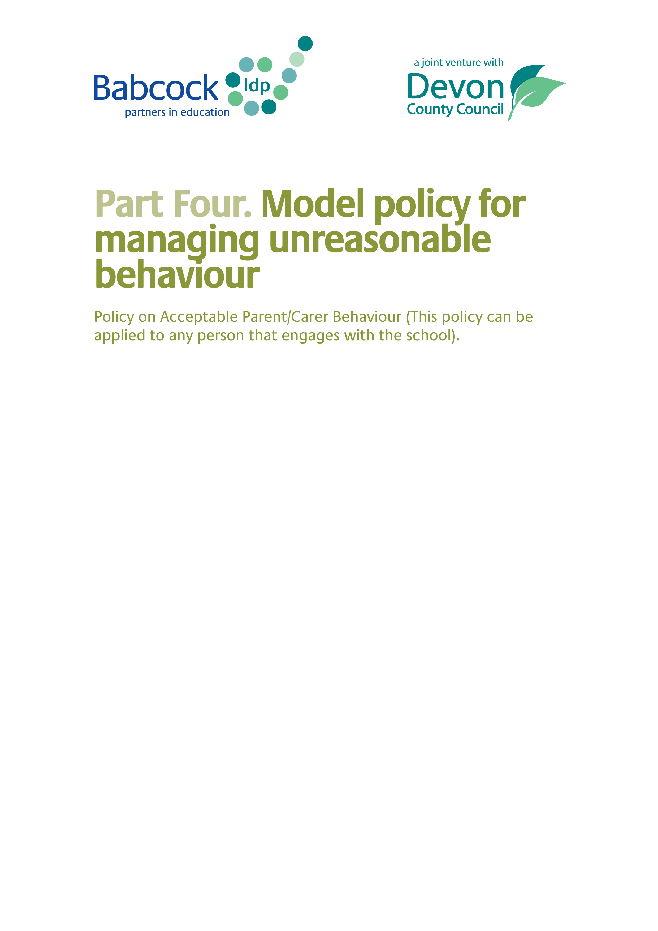

The following policy can be used whether the unreasonable behaviour is as a result on an ongoing concern or complaint which the parent has expressed about the school, or not.

At Haytor View Community Primary School we recognise that parents and carers are the single biggest influence on their children and their achievements. Therefore, we are committed to building positive and responsive relationships with parents and carers so that together we can ensure that our young people get the most out of their time with us.

Haytor View Community Primary is committed to dealing with all complaints fairly and impartially, and to providing a high quality service to those who complain. We will not normally limit the contact complainants have with our school. However, we do not expect our staff to tolerate unacceptable behaviour and will take action to protect staff from that behaviour, including that which is abusive, offensive or threatening.

We encourage partnerships with our parents and carers, and work hard to maintain mutual respect and recognition of shared responsibility for the children. However, in a very small minority of cases, the behaviour of a few parents or carers can cause disruption, resulting in abusive or aggressive behaviour towards staff and this will not be tolerated. All members of the school community have a right to expect that their school is a safe place.

Haytor View Community Primary defines unreasonable behaviour as that which hinders our consideration of complaints because of the frequency or nature of the complainant’s contact with the school, such as, if the complainant:
- refuses to articulate their complaint or specify the grounds of a complaint or the outcomes sought by raising the complaint, despite offers of assistance
- refuses to co-operate with the complaints investigation process
- refuses to accept that certain issues are not within the scope of the complaints procedure
- insists on the complaint being dealt with in ways which are incompatible with the complaints procedure or with good practice
- introduces trivial or irrelevant information which they expect to be taken into account and commented on
- raises large numbers of detailed but unimportant questions, and insists they are fully answered, often immediately and to their own timescales
- makes unjustified complaints about staff who are trying to deal with the issues, and seeks to have them replaced
- changes the basis of the complaint as the investigation proceeds
- repeatedly makes the same complaint (despite previous investigations or responses concluding that the complaint is groundless or has been addressed)
- refuses to accept the findings of the investigation into that complaint where the school’s complaint procedure has been fully and properly implemented and completed including referral to the Department for Education
- seeks an unrealistic outcome
- makes excessive demands on school time by frequent, lengthy and complicated contact with staff regarding the complaint in person, in writing, by email and by telephone while the complaint is being dealt with
- uses threats to intimidate
- uses abusive, offensive or discriminatory language or violence
- knowingly provides falsified information
- publishes unacceptable information on social media or other public forums.
Complainants should try to limit their communication with the school that relates to their complaint, while the complaint is being progressed. It is not helpful if repeated correspondence is sent (either by letter, phone, email or text), as it could delay the outcome being reached.
Whenever possible, the headteacher or chair of the governing board will discuss any concerns with the complainant informally before applying an ‘unreasonable’ marking.
If the behaviour continues, the headteacher will write to the complainant explaining that their behaviour is unreasonable and ask them to change it. For complainants who excessively contact Haytor View Community Primary causing a significant level of disruption, we may specify methods of communication and limit the number of contacts in a communication plan. This will be reviewed after six months.
In response to any serious incident of aggression or violence, we will immediately inform the police and communicate our actions in writing. This may include barring an individual from Haytor View Community Primary .Schools are not public places and although parents and carers have rights to attend and enter school premises for legitimate proper purposes, The Education Act of 1996 states that it is an offence for a trespasser on school premises to cause a nuisance or disturbance. The school is entitled to withdraw the implied right a parent or carer has to enter the school, if that parent or carer is violent or aggressive. If the parent or carer then enters the premises, they are in breach of the law, and they can be prosecuted in the criminal courts.
This policy applies to all those that engage with the school and not just to parents.
Behaviours which can lead to a ban include:

- Physical or verbal threats towards staff, pupils, or other parents
- actual violence,
- damage to property
- refusal to leave when asked
- disruption of the running of the school
- general abusiveness

The headteacher will decide whether the situation has been reached for proposing an actual ban. In extreme circumstances, i.e. if the incident is considered to be very serious, then s/he can issue a short-term temporary ban immediately, if required.

If the issue presents a less immediate threat then the headteacher will consider issuing a warning letter which says that repeats of such behaviour will likely result in a ban. Events may occur in a number of stages and it may be that upon consideration by the headteacher that a warning letter needs to be issued.

The school will write to the parent/carer setting out:

- what has happened and why it is unacceptable
- that the school will consider banning the parent/carer from the school premises
- give a clear explanation of why the ban is proposed
- give the parent/carer 5 working days to respond in writing giving their own version of events
- state the length of the proposed ban and give a review date.

Following receipt of the written response:

- The headteacher will decide whether or not to ban the parent/carer
- The parent/carer will be informed in writing within 3 days of the decision taken
- The terms of any ban will be clear, with explicit paths of communication between the school and the parent
- Pick up and drop off of children will be taken into consideration
- A date for the review will be given, which will take account of what has happened in the interim period
- If no further concerns have arisen regarding the parent’s behaviour, a meeting date will be set which will seek to re-establish a productive working relationship between the school and the parent/carer

If a parent/carer wishes to appeal against a ban, they may do so in writing (following the complaints procedure). The first stage of this appeal will be undertaken by an appointed governor who would invite the headteacher to review the matter with a view to lifting the ban. If the outcome to this stage is that the ban is still in place, then the parent may appeal further to a panel of governors according to the usual complaints process.

In some cases the unacceptable behaviour is so extreme (for example, an assault on a member of staff) that the headteacher may feel that there is no alternative but to impose a lengthy or permanent ban. In criminal cases the headteacher should inform the police and should contact their legal advisors (DCC Solicitors in maintained schools).

