

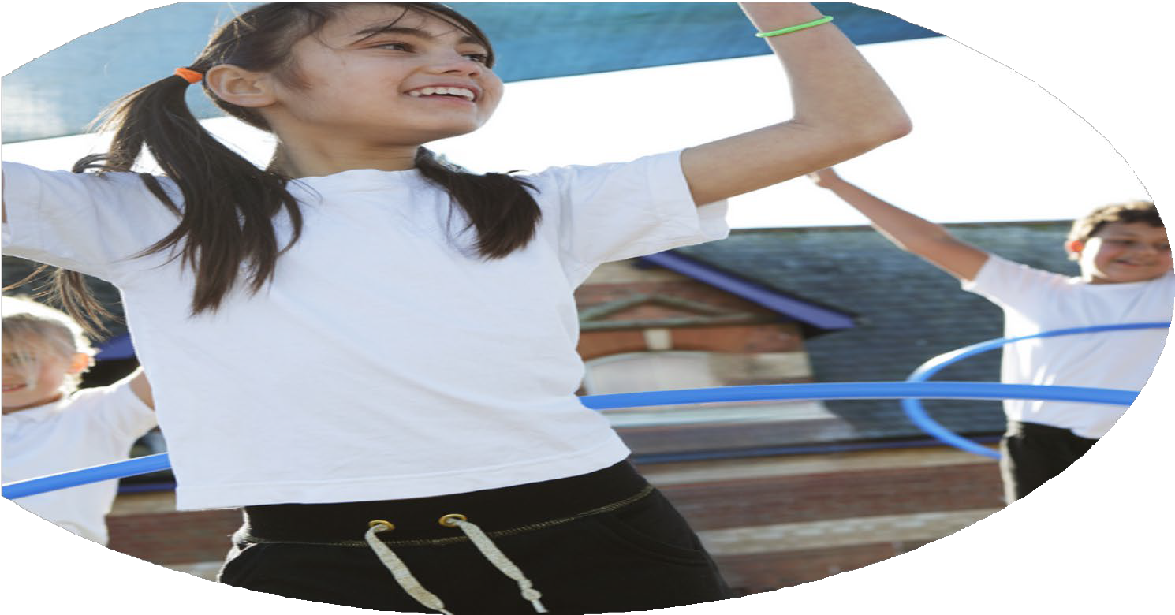
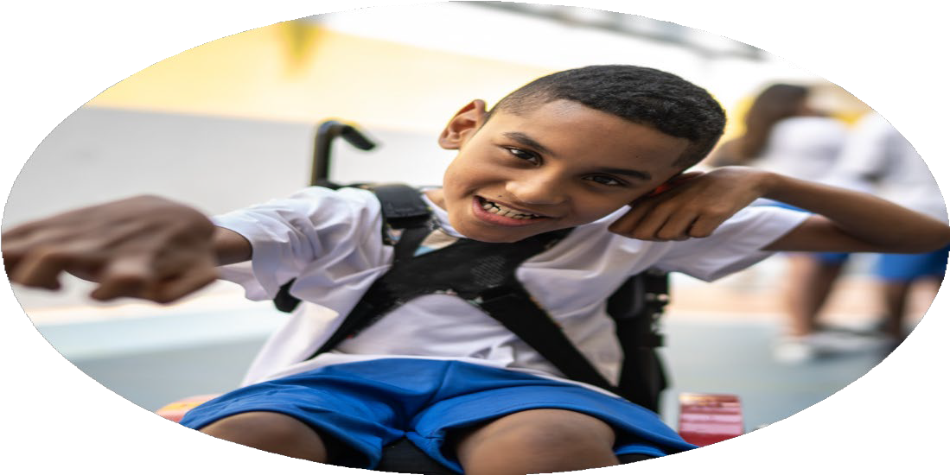




PE Funding

Evaluation Form

Commissioned by

Created by

Images courtesy of Youth Sport Trust

PE Funding Evaluation Form

It is intended that this template should be used as preparation for the completion of the statutory digital reporting tool being introduced this academic year. You can upload data (including swimming) from this template onto this platform once it becomes accessible.
Before you decide how you are going to use the funding for this academic year you should reflect and evaluate the impact of your use of the funding in 2024/25.
All spending of the funding must conform with the terms outlined in the Conditions of Grant document. The template is a working document that you can amend/update during the year.
Based on your evaluation of last year’s funding you should decide what you intend to do this academic year, how you will do it, and what impact you expect it to have.

It is important that the funding is used effectively and based on your school’s needs.
You must use the funding to make additional and sustainable improvements to the PE and sport in your school. You must develop and add to the PESSPA activities that your school already offers.

Summative digital reporting from June 2025 will continue to include swimming and water safety information therefore funding can be used to provide top-up lessons where necessary to ensure pupils meet national curriculum swimming requirements.
We recommend that you start by reflecting on the impact of current provision and reviewing your previous spend

What went well? | How do you know? | What didn’t go well? | How do you know?
Over the past academic year, Sports Premium funding has had a significant positive impact on physical education provision, pupil engagement, and staff development across the school.  High-Quality PE Delivery  - Children took part in “impact days” led by a sports professional who worked closely with teachers to deliver high-quality, first-wave PE lessons. This upskilling of staff has directly improved the delivery of PE across all year groups. Teaching assistants also participated in these sessions, supporting the wider school staff in growing their confidence and skills in teaching specific areas of PE.  Pupil Engagement and Skill Development  - Pupils engaged in inter-school competitions and developed a wide range of fundamental movement and sport-specific skills.  - Collaborative activities across different year groups fostered teamwork and peer learning.  - SEN pupils and reluctant participants were supported through tailored activities outside the classroom, leading to increased participation and enjoyment.  Creative and Cross-Curricular Enrichment  - Pupils engaged in two storytelling dance workshops that combined physical movement with learning in other curriculum areas:  - One workshop was linked to Religious Education and provided children with a culturally diverse experience through dance, enhancing their understanding of global traditions.  - The second workshop was linked to World Book Day, where pupils retold stories from their favourite books through creative movement and dance.  - These experiences also strengthened cross-curricular links with music and RE, while developing students’ expressive and physical literacy through dance.  Active Playtimes and Daily Activity  - Playleaders collaborated with the School Sport Partnership (SSP) and MTA to embed more active playtimes.  - Children participated in 30 minutes of structured activity each day, contributing to healthier, more active lifestyles.  - Bushcraft activities also supported physical literacy and helped children develop teamwork and resilience through outdoor learning.  Resources and Equipment  - Funding was used effectively to purchase additional resources and equipment, ensuring all children had access to the tools necessary to develop key skills in a range of sports.  - Increased availability of equipment meant that all pupils, regardless of ability, could take part and improve their sporting confidence and competence.  Extra-Curricular Sport Provision  - Children had access to a broad and inclusive range of extra-curricular sports clubs provided by Premier Education, which rotated on a half-termly basis to offer variety and widen participation.  - These clubs catered for different interests and abilities, contributing to increased overall physical activity levels across the school.  Swimming  - Additional qualified instructors were deployed to work with targeted children who required further support to meet age-related expectations in PE. These smaller group sessions allowed for more focused, personalised teaching, which increased skill development and confidence.  - The use of specialist staff ensured high-quality instruction that complemented class teacher delivery, helping to close gaps in physical competence and understanding for children who needed it most.  - Swimming provision was extended to include Year 2 pupils, alongside Year 5, offering younger children early exposure to swimming skills and water safety.  - This additional swimming time for Year 2 allowed pupils to build foundational skills in a less pressured environment, preparing them for future expectations in KS2.  - Year 5 children benefited from a longer, more consistent swimming programme, giving more time for non-swimmers and those with anxiety around water to make measurable progress. | We have drawn on a variety of evidence sources to understand and demonstrate the positive impact of Sports Premium funding:  Pupil Voice and Engagement  - Pupil feedback following impact days, dance workshops, and extra-curricular clubs has been consistently positive.  - Children have shown increased enjoyment of PE and physical activity, especially those who were previously reluctant or less active.  - SEN pupils have become more confident and engaged due to targeted and inclusive physical activities.  Teacher and Staff Feedback  - Teachers have reported increased confidence and subject knowledge after working alongside a sports professional and the School Sport Partnership (SSP).  - Staff have reflected on their practice and used guidance from the SSP to develop and improve their delivery of PE lessons.  - There is now a strong, shared understanding among staff of the fundamental skills required for each sport, ensuring consistency and progression across year groups.  - Teaching Assistants have also shared that they feel better equipped to support pupils during PE lessons.  Increased Participation  - More pupils are taking part in extra-curricular sports clubs, including those from underrepresented groups.  - All year groups have regularly participated in daily physical activity, inter-school competitions, and enrichment events.  Observations and Monitoring  - Informal lesson observations indicate improved PE delivery, with more engaging and inclusive activities being taught.  - Children are more physically active at break and lunchtimes due to structured active play led by trained playleaders.  - The bushcraft activities have led to increased collaboration, resilience, and enthusiasm for outdoor learning.  Cross-Curricular Impact  - Curriculum planning and classroom displays reflect meaningful links between PE and other subjects, such as RE, Literacy, and Music.  - Pupils demonstrated creativity, teamwork, and expression during dance workshops, with visible outcomes through performances and classroom engagement.  Swimming  - Targeted pupils receiving additional support made noticeable gains in confidence, coordination, and physical ability, helping more pupils to access the full PE curriculum successfully.  - There was improved progress toward national curriculum outcomes.  - The earlier introduction of swimming in Year 2 helped to reduce anxiety around swimming lessons later on and gave children with less water experience a head start on basic techniques.  - More Year 5 pupils met or exceeded national swimming expectations compared to previous years, due to increased exposure and personalised support during lessons.  - Pupil feedback indicated high levels of enjoyment and perceived progress in swimming, especially among those who had little or no previous access to formal lessons.  - Staff noted that early swimming also helped develop children's resilience and self-regulation, as well as improving overall participation in PE. | While there have been many successes this year, a few areas presented challenges or did not have the desired impact:  Inconsistent Participation from Some Pupils  - Despite increased opportunities, a small number of pupils, particularly those with high levels of anxiety or social needs, continued to be reluctant to engage in group sports or physical activity.  - Additional support was put in place, but some pupils still require further, more personalised intervention to boost participation and confidence.  Limited Indoor Space During Poor Weather  - Access to indoor spaces during poor weather limited the ability to deliver lunchtime provision particularly in colder months. As a result, some planned PE sessions or lunchtime activity had to be shortened or adapted, reducing impact and engagement.  Time Constraints for Staff CPD  - Although teachers and TAs benefitted from impact days, scheduling regular CPD alongside daily teaching commitments proved challenging.  - Some staff expressed a need for more time to embed the learning from sessions and reflect more deeply on their practice.  Limited Parental Engagement  - Efforts to increase parental involvement in active events and after-school clubs saw limited take-up in some year groups.  - This suggests the need to explore different communication strategies or formats to better engage and inform families.  Limited Access to Inter-School Competitions  - Although pupils participated in some inter-school sports events, opportunities for wider competitive experiences were reduced.  - The increasing cost of transport made it more difficult to attend external sporting competitions, limiting the number of children able to represent the school against others | To understand where impact was limited, we gathered evidence through pupil and staff voice, attendance data, informal observations, and activity records:  Inconsistent Participation from Some Pupils  - Staff reported that, despite a wide range of activities being offered, a small number of pupils continued to show reluctance or disengagement.  - These pupils were often observed withdrawing from group activities or requiring additional encouragement and support to take part.  - PE lesson engagement and club attendance logs also reflect inconsistent participation among some children with additional needs.  Limited Indoor Space During Poor Weather  - Staff feedback highlighted frustration around lack of consistent indoor access, which impacted planning and delivery.  Time Constraints for Staff CPD  - While impact days were well received, staff indicated through feedback that ongoing CPD time was limited due to busy schedules.  - Some teachers shared that although they had learned new strategies, they lacked sufficient time to reflect and implement them fully in their weekly practice.  Limited Parental Engagement  - Attendance logs for events such as after-school clubs indicated lower than expected turnout from some year groups.  - Feedback from staff suggested that communication efforts, such as newsletters or app notifications, did not always result in parental involvement.  - Few families responded to invitations to attend or support physical activity events.  Limited Access to Inter-School Competitions  - Fewer inter-school sporting events were attended this year compared to previous years, as recorded in the PE coordinator's event log.  - Staff cited the rising cost of coach and minibus transport as a barrier to participation, which was also reflected in budget planning records.  - Pupils also expressed disappointment at fewer opportunities to represent the school competitively.

What are your plans for 2025/26? | How are you going to action and achieve these plans?
Intent | Implementation
In 2025–2026, our PE and Sport Premium will be used to further enhance engagement, inclusivity, and physical literacy across the school. Our key intentions include:  - Increasing engagement among reluctant participants, with targeted support and inclusive opportunities designed to build confidence and enjoyment in physical activity.  - Developing pupils’ physical literacy through structured provision that supports fundamental movement skills and fosters lifelong healthy habits.  - Expanding participation in inter-school sporting festivals and competitions by providing transport, allowing more children to experience competitive sport and represent the school with pride.  - Strengthening pupil voice in shaping their PE experiences, ensuring provision reflects their interests, motivations, and preferred ways of learning.  - Improving playtime provision to better support physical development and active play through purposeful resources and adult-led support.  - Continuing to work with Premier Education to deliver high-quality, engaging extracurricular sports clubs across the year.  - Placing greater emphasis on participation in extra-curricular activities, ensuring all children have the opportunity to access and benefit from sport outside curriculum time.  - Sustaining and developing our Play Leaders Club, with children leading and shaping activities that reflect their interests and encourage wider participation. | 1. Increase Engagement Among Reluctant Participants  - Identify target pupils through PE assessments and staff feedback.  - Provide smaller group or 1:1 sessions focused on building confidence and enjoyment.  - Offer non-traditional sports (e.g. archery, yoga, dance) to appeal to diverse interests.  - Staff training on inclusive practice and engaging disengaged learners.  2. Develop Physical Literacy for All Pupils  - Embed physical literacy objectives into PE lessons across year groups.  - Train staff on delivering activities that build coordination, balance, agility, and movement confidence.  - Use playtime and lunchtime activities to reinforce physical literacy through active play.  3. Expand Participation in Inter-School Competitions  - Allocate funding for transport to a wider range of events across the academic year.  - Track participation to ensure fair access for all groups, including disadvantaged pupils.  - Work with the SSP to schedule more festival-style and competitive events.  - Offer practice sessions or team preparation time within school.  4. Strengthen Pupil Voice in PE  - Conduct termly pupil surveys or class discussions on PE and physical activity.  - Use feedback to shape curriculum, club offerings, and playground provision.  - Introduce a “PE Ambassadors” scheme to gather regular input and promote PE in school.  5. Improve Playtime Provision to Support Physical Literacy  - Audit current playground provision and identify areas for development with the school Head Teacher and SENDCo.  - Train MTA and Play Leaders to lead active games and facilitate inclusive play.  - Continue structured play zones or rotations led by trained Play Leaders.  6. Continue Premier Education Extra-Curricular Sports Offer  - Renew contract with Premier Education to provide a broad range of after-school clubs.  - Use pupil feedback to inform the club timetable and ensure variety.  - Target attendance from less active pupils through direct invitation.  - Monitor club uptake and impact through registers and pupil voice.  7. Promote Participation in Extra-Curricular Sport  - Celebrate participation and success in sports through assemblies, newsletters, and displays.  - Offer short-term “taster” clubs to encourage new joiners and reduce anxiety about commitment.  - Work with teaching staff to identify and encourage children who are not engaging.  - Provide lunchtime activity clubs for children who cannot attend after school.  8. Develop the Play Leaders Club  - Re-launch Play Leaders training programme in autumn term.  - Provide regular check-ins and leadership support to Play Leaders.  - Involve children in planning and evaluating lunchtime games and playground activities.  - Celebrate their role and contribution through school rewards and recognition.

What impact/intended impact/sustainability are you  expecting? | How will you know? What evidence do you have or  expect to have?
1. Increased Engagement from Reluctant Participants  Impact: More pupils with low confidence or social/emotional needs will actively participate in PE and extra-curricular activities.  Intended Impact: Pupils will build self-esteem, resilience, and a positive attitude toward physical activity.  Sustainability: Staff will be trained in inclusive strategies, embedding lasting practice that supports all learners year-on-year.  2. Stronger Focus on Physical Literacy  Impact: Children will show improved fundamental movement skills and better overall physical competence across the curriculum.  Intended Impact: Pupils will gain confidence in movement, which will support their physical, social, and emotional wellbeing.  Sustainability: Resources and staff training will embed physical literacy into daily routines and PE teaching.  3. Greater Participation in Inter-School Sporting Events  Impact: More children will experience competition and teamwork in different environments, representing the school proudly.  Intended Impact: Pupils will develop sportsmanship, motivation, and a sense of belonging.  Sustainability: Links with local schools and SSP will be maintained to ensure continued access beyond this funding cycle.  4. Stronger Pupil Voice in PE and Sport  Impact: Pupils will feel listened to, resulting in higher motivation and more relevant, inclusive provision.  Intended Impact: PE will reflect pupils’ interests, increasing ownership and participation.  Sustainability: Systems such as PE Ambassadors and regular feedback will become embedded into school practice.  5. Improved Active Play Provision  Impact: Playtimes will be more active, inclusive, and purposeful, supporting physical literacy and social skills.  Intended Impact: Children will be more active throughout the school day, contributing to daily movement targets.  Sustainability: Investment in equipment and play leader development will have long-term benefit, creating a self-sustaining model led by pupils.  6. Continued High-Quality Extra-Curricular Provision  Impact: A wide range of clubs will provide opportunities for all children, including those less likely to engage outside of school.  Intended Impact: Increased uptake of clubs and a culture where physical activity is valued and celebrated.  Sustainability: Staff will build confidence through working alongside external providers, increasing capacity to deliver in future.  7. Increased Participation in Extra-Curricular Activities  Impact: Participation rates in after-school clubs and sporting activities will increase, particularly among disadvantaged or inactive pupils.  Intended Impact: A more inclusive culture around sport and physical activity across the school.  Sustainability: Targeted strategies and celebration of success will remain part of whole-school engagement plans.  8. Continued Growth of Play Leaders Programme  Impact: Pupils will develop leadership skills and a sense of responsibility, while helping to increase physical activity at playtimes.  Intended Impact: Child-led activities will enhance enjoyment and participation during less structured times.  Sustainability: Leadership roles and peer-led initiatives will become part of school culture, with each cohort training the next. | 1. Increased Engagement from Reluctant Participants  - How we’ll know: Greater participation from identified pupils in PE lessons and clubs; improved confidence and willingness to take part.  - Evidence:  - Pupil voice (targeted surveys or interviews)  - Staff information sharing  - Participation tracking logs  - Attendance registers for clubs and activities  2. Stronger Focus on Physical Literacy  - How we’ll know: Improved movement skills, control, balance and coordination across a wider group of pupils.  - Evidence:  - Teacher observations and pupil learning display  - Video/photo records of progression  - Pupil and staff feedback on confidence and skill development  3. Increased Attendance at Inter-School Events  - How we’ll know: More children attend competitions and events; more variety of year groups and needs represented.  - Evidence:  - Event attendance logs and registers  - Feedback from pupils and staff  - Photographs, certificates, celebration displays  - Participation data compared to previous year  4. Stronger Pupil Voice in PE and Sport  - How we’ll know: PE provision and extra-curricular offer reflects what pupils want; increased engagement and ownership.  - Evidence:  - Pupil surveys and focus group feedback  - PE Ambassadors’ logs or minutes from discussions  - Adjustments made to the PE curriculum or clubs in response to feedback  5. Improved Play Provision  - How we’ll know: Playtimes are more active, inclusive, and purposeful; children use resources confidently.  - Evidence:  - Observations and activity audits at play/lunchtimes  - Pupil feedback on enjoyment and inclusion  - Records of incidents or behaviour changes  - Use of new equipment and zones (monitored by staff or Play Leaders)  6. Continued Premier Education Extra-Curricular Offer  - How we’ll know: Clubs are well-attended, high quality, and varied; pupils continue to engage positively.  - Evidence:  - Club registers and attendance tracking  - Feedback from pupils and Premier Education staff  - Photographs/videos of clubs in action  - Increased variety of pupils accessing clubs  7. Increased Participation in Extra-Curricular Sport  - How we’ll know: Higher participation rates, particularly among previously inactive pupils.  - Evidence:  - Club uptake data and comparison with previous years  - Targeted pupil participation tracking  - Feedback from pupils and parents  - Celebration of involvement (newsletters, assemblies, displays).  8. Continued Play Leaders Programme  - How we’ll know: Play Leaders are confident, organised, and positively influencing playtimes.  - Evidence:  - Play Leader training records  - Timetables and activity logs  - Observations of leadership in action  - Pupil reflections and feedback

What impact/sustainability have you seen? | What evidence do you have?
- Feedback during PE lessons and clubs show that pupils are becoming more enthusiastic and confident when participating in physical activity.  - A rise in increased numbers of pupils taking part in lunchtime and after-school sports clubs.  - Positive pupil voice collected through surveys and informal discussion shows that children value PE more and enjoy the variety of sports and activities offered.  - Teachers and TAs have reported greater confidence in planning and delivering high-quality PE, particularly in areas such as dance, invasion games, and fundamental skills.  - Monitoring and information sharing show a more consistent standard of PE delivery across year groups, with improved structure and progression in lessons.  - Photographs, certificates, and displays begin to showcase pupil achievements and encourage further engagement.  - Bushcraft and outdoor learning sessions have promoted teamwork and physical resilience, evidenced through pupil reflection and staff observation. SEN and anxious pupils have demonstrated improved engagement in both PE lessons and outdoor physical activities, supported by differentiated tasks and safe, supportive environments.  - Work samples and pupil reflections from storytelling dance workshops show strong links between physical education and curriculum areas such as RE, Literacy, and Music.  - Teachers report that these experiences deepened pupils’ understanding of cultural and narrative content while developing their expressive movement skills. | We have collected a wide range of qualitative and quantitative evidence to demonstrate the positive impact of the PE and Sport Premium funding in 2024–2025:  - Club registers showing increased pupil participation in extracurricular sport, including a rise in attendance from reluctant and SEN pupils.  - Event records and photos evidencing wider participation in inter-school competitions and festivals across different year groups.  - Teacher and TA evaluations following PE Impact Days show increased confidence and skill in delivering high-quality lessons.  - Verbal feedback from pupils, particularly those supported in small group or outdoor sessions, highlights increased confidence and enjoyment.  - Photographs and videos from PE lessons, clubs, competitions, and workshops are displayed and used to celebrate pupil participation.  - Certificates, stickers, and awards are used to acknowledge sporting achievement and engagement across all ability levels.  - Displays and newsletters showcase sporting highlights and pupil voice, reinforcing the school’s positive culture around physical activity.  - Play Leader reflections show the development of pupil leadership skills and increased structure in playtimes.  - Reports and informal feedback from Premier Education and SSP staff confirm strong pupil engagement, good behaviour, and enthusiasm across clubs.  - The School Sport Partnership (SSP) and South Devon Community Cricket has praised the school’s approach to inclusive competition and active playtimes.

