Hello Year 3!
I hope you are all staying safe and becoming fantastic vocabulary detectives and fast typists!
Now, you all know that occasionally, I like to set you a Miss Wicks Challenge! Well, I have one that I think you will love, I have thoroughly enjoyed giving it a go myself!!! So, have you got what it takes to take on my challenge?

The Purple Mash Festive Card Competition

This Photo by Unknown Author is licensed under CC BY-NC
DEADLINE DATE = 23rd November and judging takes place on the 25th November 2020.

To enter you simply design your own festive card using PURPLE MASH TOOL 2PAINT A PICTURE.
You have many choices of how your design will look - from acrylics to pattern, ink, pointillism, collage, and many more exciting designs.

All winners will receive 10 printed copies of their card along with a £10 Amazon voucher and a 2Simple goody bag and all winning cards to will be turned into Purple Mash E-cards which means that you don’t have to send a physical card at a time when we are all trying to stay safe.

So, get those creative ideas flowing and get designing………. When your happy with your design – Save to your work area and I will arrange sending your creation to Purple Mash.
Here is my entry - using Collage – NO LAUGHING!!!!!
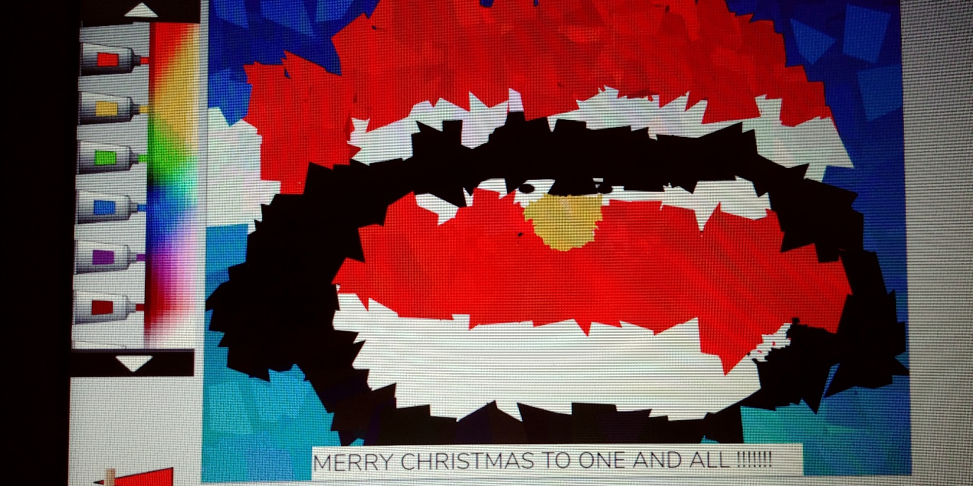
Can you guess what it is?

