Minibeast name | Root words | Etymology | Picture
Millipede | Milli  Pede | Latin: mille ‘thousand’.  Latin: Ped – foot  A millipede has a thousand feet. | 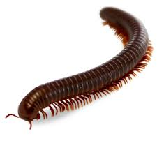
Butterfly | Butter  Fly | The first noted species were cream/yellow coloured like butter.  Middle English term flye  A butterfly looks like flying butter! | 