13.11.18. due in on 19.11.18.
Maths Home Learning

46 + = 100 65 - = 29
+ 56 = 93 - 17 = 21
37 + 88 = 21 + 17 =
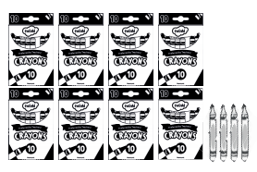
There are 10 pens in a packet. How many pens does Archie have?__________
He gives 23 pens away. How many pens has he left? ________
Jayden has 50 sweets, he gives 12 to Maxx and 18 to Lennon. How many sweets does he have left?

Jack thinks 20 – 7 = 12. Is he right?
Explain your thinking.

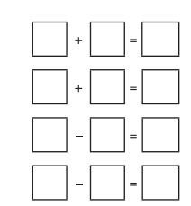
Use these numbers to create 4 number sentences.
23, 6, 29

