Maths Home Learning Wc 23.04.19 Due 29.04.19
Rounding – To the nearest 10
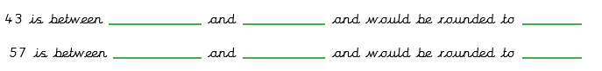
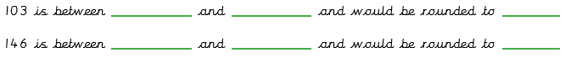
Rounding – To the nearest 100
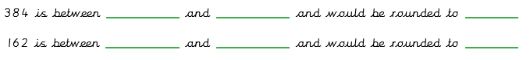
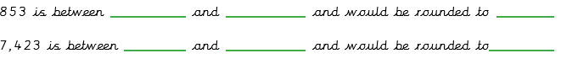
Rounding – To the nearest 1000
