Maths Home Learning wc 14.01.2019. due 21.01.1019
Multiplicative Reasoning
Use your times table learning to attempt the following:
Write a number sentence to show your thinking.
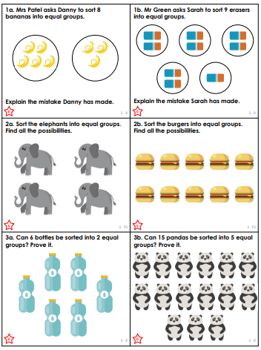
Use this space to show your thinking.
1a)
8 ÷ 2 = 4
4 x 2 = 8

1b)

2a)

2b)

3a)

3b)

