Maths Home Learning
(Wc25.02.19 Due 04.02.19)
Revisiting previous learning:
Continue this sequence that crosses a boundary.
277,287,______,______,______,______.
Partition the following number into H T U/O 4 2 6
/ \ \

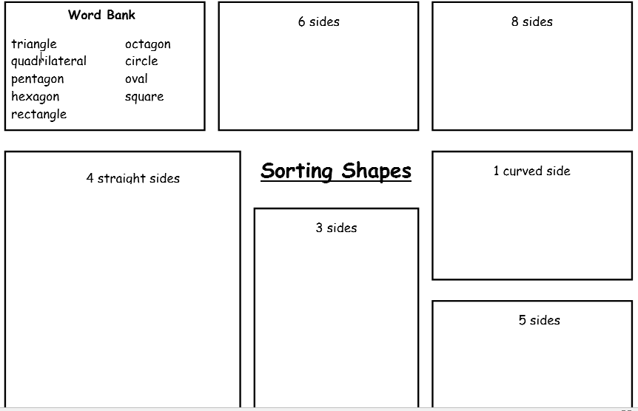
Label the triangles – Isosceles , scalene or equilateral


  

