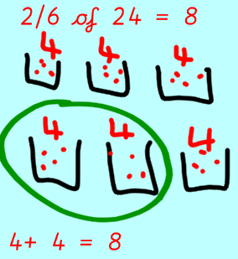
Maths Home Learning
In maths this week we have been finding fractions of amounts by sharing. We do this by first looking at the denominator (bottom number) to find out how many groups we are sharing into. Then we share the total amount into these groups.
Next we look at the numerator (top number) to know how many groups we need to count.
Please follow the example from our learning in class to solve the problems below:
3/ 4 of 20 =

4/6 of 30 =

2/8 of 32 =

There were 28 children in year three. 1/7 of them ordered Deli bar for lunch. How many year 3s ordered Deli bar?

How many did not order Deli bar?

