Name:
Maths Home Learning
Wc 11.11.19. due Wc 18.11.19.
LI: To revise maths learning on number bonds (100).
What number bond for 100 is shown below.

+
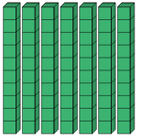
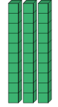
Fill in the missing number to make number bonds to 100 and show this on a number line.
50 + ______ = 100 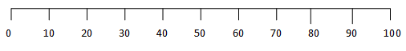

70 + ______ = 100

20 + ______ = 100

40 + ______ = 100

Draw your own number line to show:
(If you feel stuck look at the number lines in the previous question for help.)

60 + ______ = 100

_____________________________________________________________________________________________________________

