Maths Home Learning
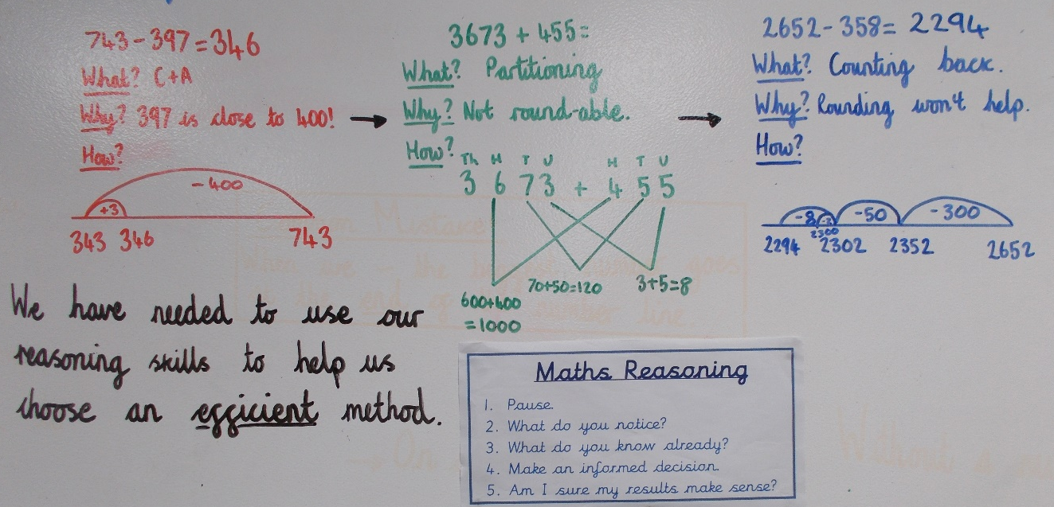
This picture shows the methods we have been using in maths this week. For each question below, select one of the methods above. You should be considering why you are choosing each method.

1.3095 – 273 =

2.4072 + 399 =

3.7805 – 997 =

4. 8057 + 1937 =

5. 2063 – 998 =

6. 8036 + 255 =

7.3801 – 2430 =

8. I bought a packet of crisps (99p) a carton of juice (£2.01) and a magazine (£2.98) from Co-op. How much did I spend?

9. The football pitch was 120m long. I ran half the distance and jogged for another 36m. How much further did I have to go to get to the end?

