Tuesday 21st January 2020
Due in Monday 27th January 2020

Maths Home Learning – Symmetry

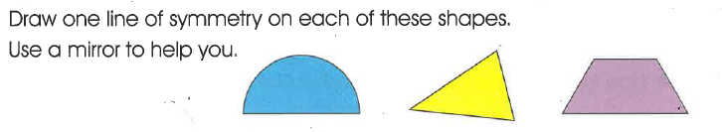
1)

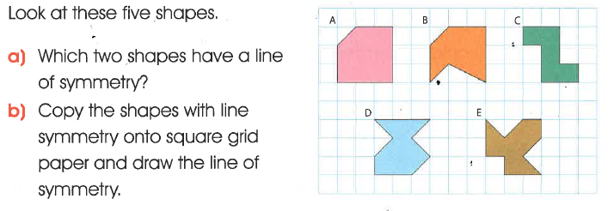

2)

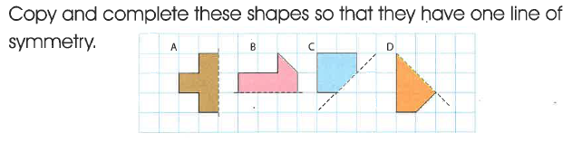
3)

4)

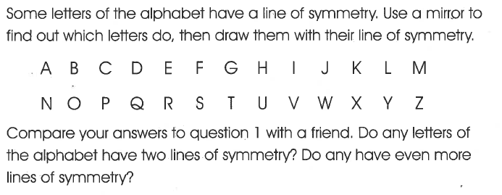
5)

