In maths this week we have been learning about fractions. We know that fractions are part of a whole and that we can find fractions of shapes and numbers.
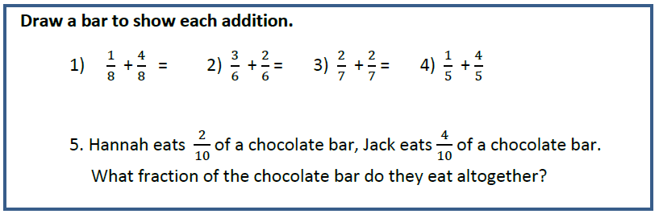
We also know that when we add fractions with the same denominator (bottom number) the denominator does not change. The bar models help us to see why that is.
1. =

2. =

3. =

4. =

5. =

