Maths Home Learning Wc 23.04.19 Due 29.04.19
Comparing and Ordering Numbers
Comparing Numbers - Greater than or less than
Insert the > greater than or less than < symbol
- 4753 4573 b) 8383 8838 c) 2794 2947

d) 6392 6239 e) 5555 5610 f) 1053 1109

Ordering Numbers
Write these numbers out in their digit form and order them from smallest to largest.
Nine thousand five hundred and five - _______________________________
Two thousand and two - __________________________________________________
Four thousand six hundred and ninety two - ________________________________________
Six thousand two hundred and twenty nine - ________________________________________
__________________________________________________________________________________________________________________________

Rearrange the digits to make the lowest and highest possible four-digit number each time. You cannot begin with 0.
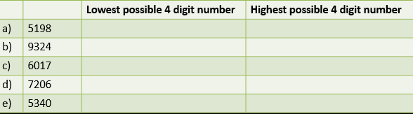

Use the digits 2, 3, 5 and 7 to make four-digit numbers higher than 7000. You can only use each digit once in each number. (E.g. you cannot make the number 7552 as you have used 5 twice).
___________________________________________________________________________
___________________________________________________________________________
___________________________________________________________________________
___________________________________________________________________________

