Tuesday 11th June 2019
Due in Monday 17th June 2019

Maths Home Learning
(Column Method for Addition)

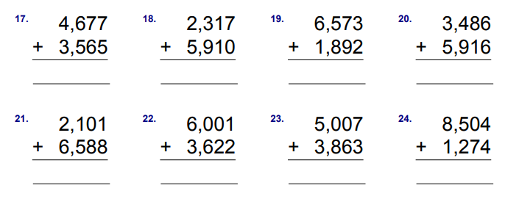
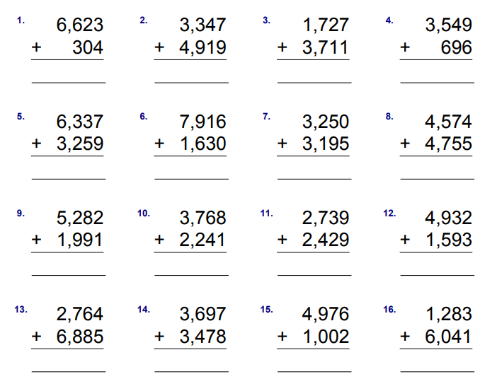
Use the column method to work out the number sentences below. Make sure you add from the units/ones first.

