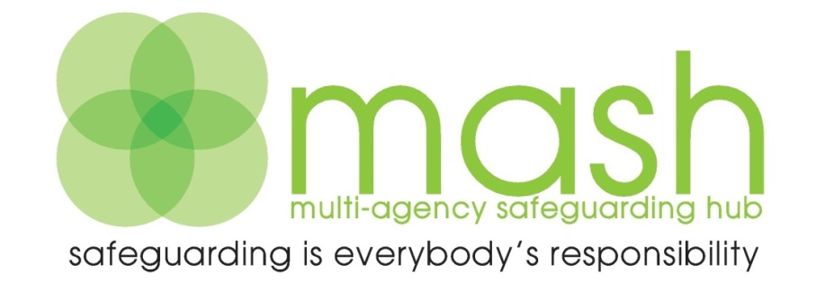

For Early Help, Consultation and Enquiries please contact:
Telephone: 0345 155 1071
Email: mashsecure@devon.gov.uk
Fax: 01392 448951
Enquiry Form available at:
https://new.devon.gov.uk/making-a-mash-enquiry

Post: Multi-Agency Safeguarding Hub, P.O. Box 723, Exeter EX1 9QS
Emergency Duty Team out of hours 0845 6000 388
Police non-emergency 101

For all LADO enquiries Exeter (01392) 384964
https://new.devon.gov.uk

Early Help Team

Senior Manager: TBC
Manager Exeter and South: TBC
Manager Mid & East: Ian Flett 07815 562 370
Manager South & West: Karen Hayes 07854 253424
Manager Northern: Sarah Simpson 07854 304 512

Locality Early Help Mailbox
North: earlyhelpnorthsecuremailbox@devon.gov.uk
Mid & East: earlyhelpmideastsecuremailbox@devon.gov.uk
South & West: earlyhelpsouthsecuremailbox@devon.gov.uk
Exeter: earlyhelpexetersecuremailbox@devon.gov.uk

For emergencies outside of office hours please call:
0345 600 0388 or 0845 600 0388

