Draw lines to match each sentence to its correct function.
Question
I think that she will win the match
on Saturday.
Command
Can you come to the game with me?
Exclamation
Check the kick-off time before deciding
to come.
Statement
What a fantastic goal!
Re-arrange the words in the statements below to form questions. Use only the given words.
E.g. Statement: Miss Shopland does like the colour green.
Question: Does Miss Shopland like the colour green?

Statement: The boys are playing a game.
Question:

Statement: It is raining outside.
Question:

Write a question and a statement of your own about the picture.
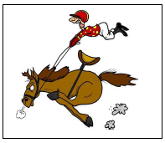
Statement:

Question:

