Monday 9th November 2020

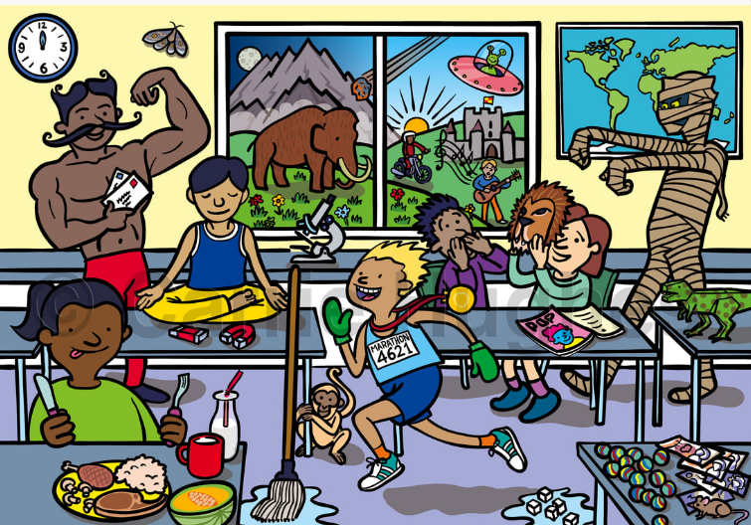
Writing Interesting Sentences

Write sentences to describe what is happening in the picture.
__________________________________________________________________________________________________________________________________________________________________________________________________________________________________________________________________________________________________________________________________________________________________________________________________________________________________________________
Challenge 1:
Uplevel three of your sentence by adding interesting adjectives. e.g. The happy runner ran across the classroom.
_____________________________________________________________________________________________________________________________________________________________________________________________________________________________________________________________________

Challenge 2:
Write 3 sentences including an expanded noun phrase e.g. The happy runner, with the green gloves, ran across the classroom.
___________________________________________________________________________________________________________________________________________________________________________________________________________________________________________________________________________________________________________________________________________________________________________________________________________________________________________________

Challenge 3:
Write 3 sentences including a fronted adverbial e.g.
Happily, the boy, with the green gloves, ran through the classroom.
___________________________________________________________________________________________________________________________________________________________________________________________________________________________________________________________________________________________________________________________________________________________________________________________________________________________________________________
Super challenge:
Can you write your sentence in another way e.g. The boy, with the green gloves, ran happily through the classroom.
____________________________________________________________________________________________________________________________________________________________________________________________________________________________________________________________________________________________________________________________________________________________

