English Home Learning – Investigating Vocabulary
Wc Monday, 14th October 2019 due Monday, 28th October
Draw a picture | Vocabulary Word | Meaning / Definition
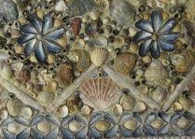 | Studd(ed) | To cover or be covered with small things – like shells.  It might look similar to a mosaic.
 | Clickety
 | Piped
 | Rustle(d)
 | Stitch(ed)
 | Growl(ed)
LI: To investigate words from the book ‘The Beasties’.

