Tuesday 6th November 2018

English Home Learning
Expanded Noun Phrases

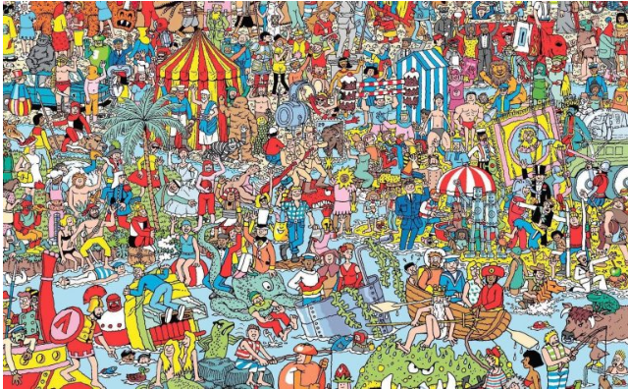

- Can you find the man?
- …I’m sorry I’m not being specific enough, can you find the smiling, strong man?
- ….still too hard?
- Can you find the tall, strong, smiling man with a blue hat and an axe? Once you have found him circle him.

Come up with four of your own descriptions for people in the pictures for your friends to use. Can you expand it even further to include with, that or which.

1.______________________________________________________________________________________________

2._____________________________________________________________________________________________

3._____________________________________________________________________________________________

4._____________________________________________________________________________________________

