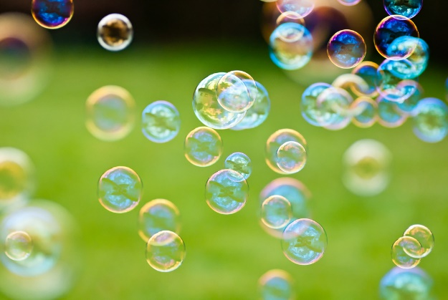
Bubble song

1 little, 2 little, 3 little bubbles
4 little, 5 little, 6 little bubbles
7 little, 8 little, 9 little bubbles
10 little bubbles to pop!
Pop, pop, pop little bubbles
Pop, pop, pop little bubbles
Pop, pop, pop little bubbles
10 little bubbles to pop!


