Arrays
What is an array?
An array is where objects are grouped in columns and rows.

Arrays can help us to count more efficiently.

For example:
Here I can group the eggs into lots of 2.

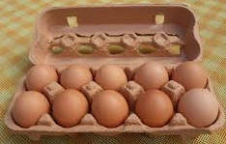
2 2 2 2 2

2 + 2 + 2 + 2 + 2 = 10 There are 5 lots of 2.

That was quicker than counting each of the eggs!

Let’s try again with bumps on the Lego brick. I wonder how many bumps there are?
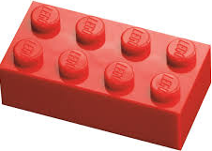

2 2 2 2

2 + 2 + 2 + 2 = 8 There are 4 lots of 2.

Now it’s your turn!



…… …… …… ……

There are ...... lots of ......

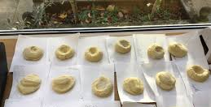
…… …… …… …… …… ……

There are …… lots of ……

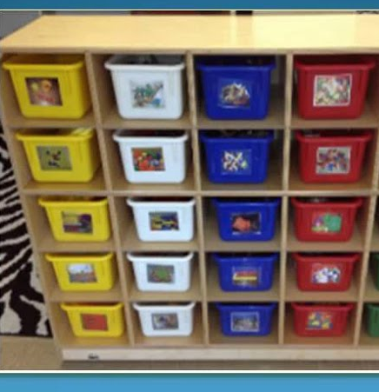
…… …… …… ……

There are ….. lots of ……

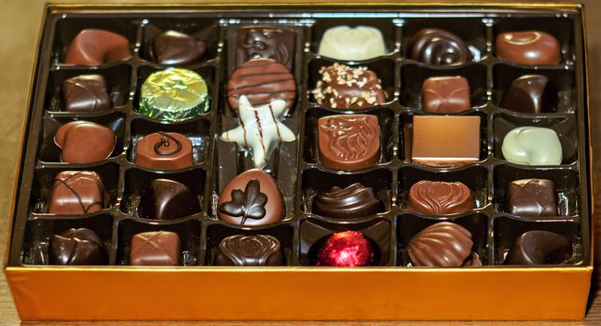

…… …… …… …… …… ……

There are …… lots of ……



…… …… ...... ……

There are …… lots of ……

Can you spot any arrays around your home? Can you create different arrays using your toys or other things around your home?

Have a go at drawing your own arrays.

