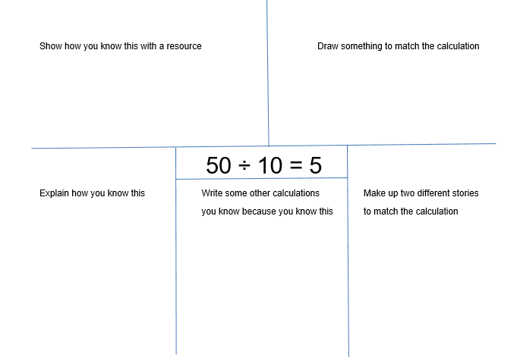
APPENDIX 9 DUG Grid Years 3 & 4

