
Haytor View Community Primary School & Nursery
Information Sharing to support Professional Development Policy
2022 - 23
Learning together - enjoying success - aiming high - celebrating difference – enriching community

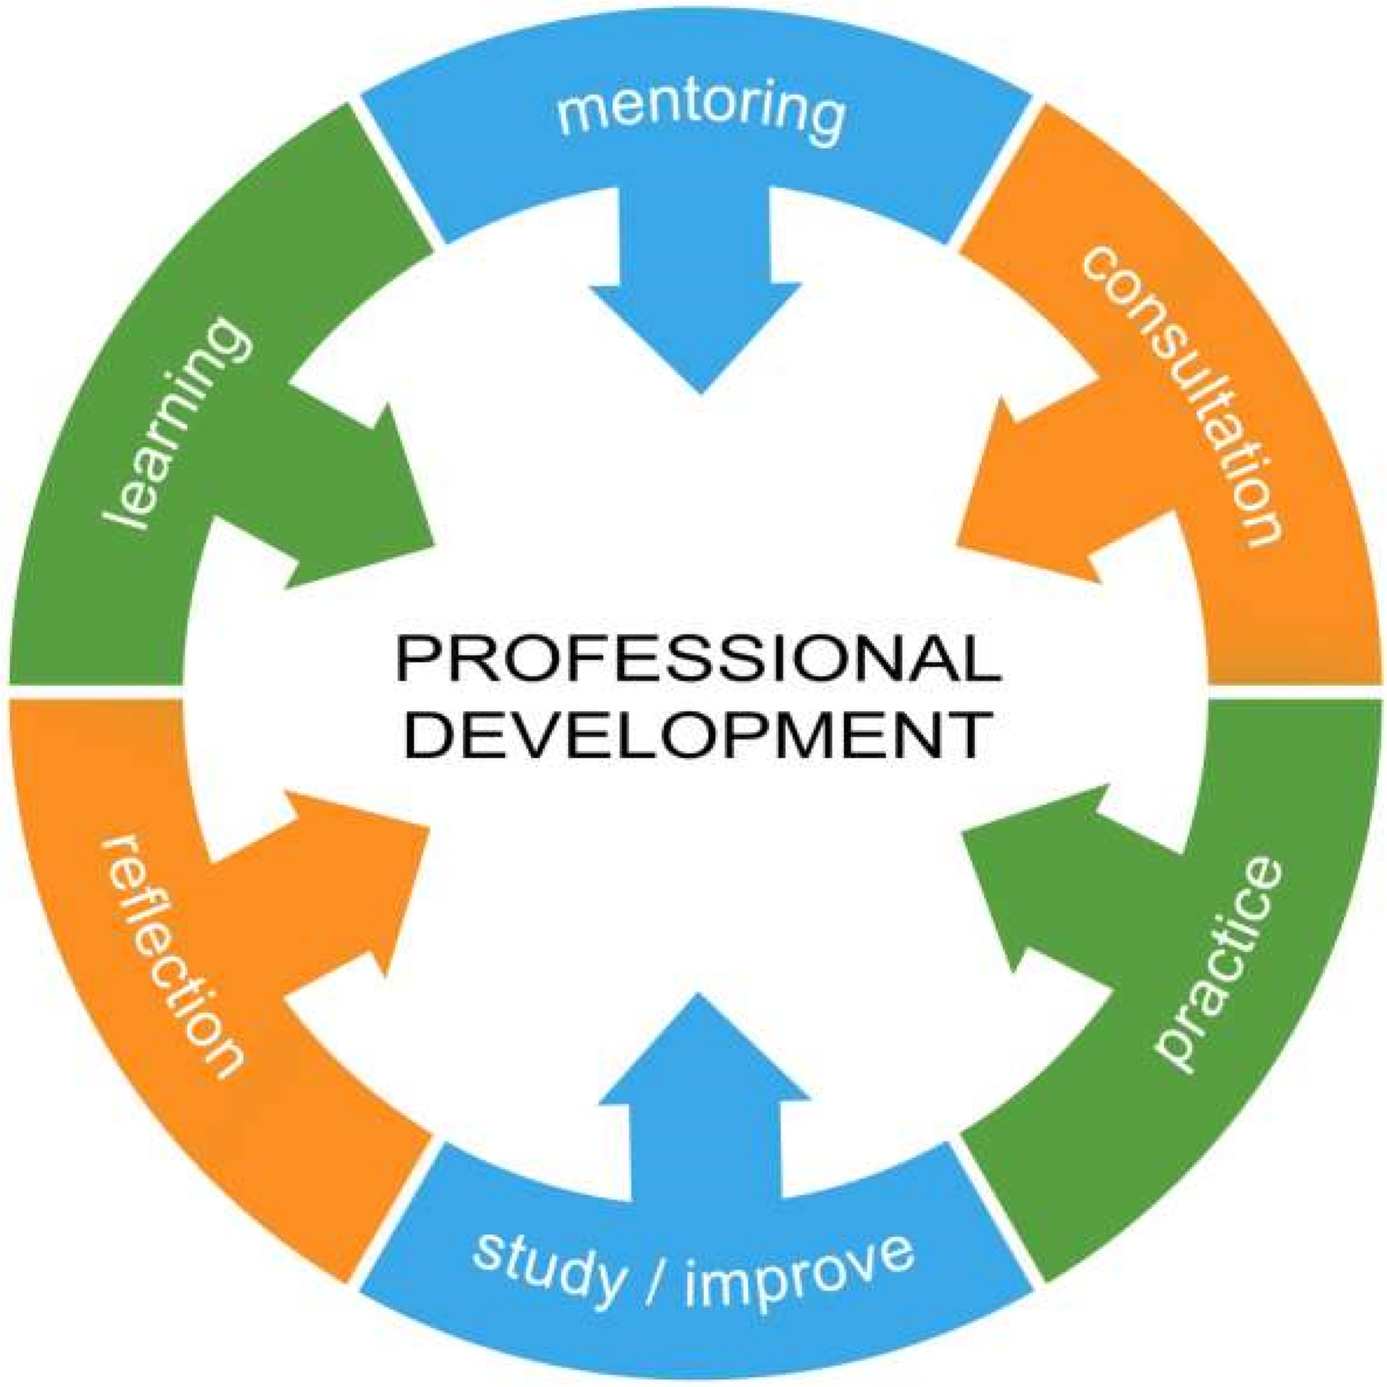
RATIONALE
Haytor View Community Primary School is a ‘learning community’ where all staff are involved in a continuous process of development in line with the school’s ethos and strategic aims. We are committed to fostering a positive climate for continuous learning amongst its community. Continuing professional development is the means by which the school is able to develop its professional community.

We believe that ‘effective practitioners should take ownership and give a high priority to their own professional development’, reflecting the principles detailed in Ofsted and the Professional Teaching Standards. A coherent strategic approach to supporting practitioner development improves provision and outcomes for children.

It is the role of every practitioner to evaluate the impact of our teaching on children’s learning and progress, every interaction we have with children has an impact on pupils’ learning, therefore it is critical that we reflect on the impact of our teaching to secure the success of each child.

High quality first wave teaching has the biggest impact on outcomes for children, therefore we continually drive development of high quality Wave 1 teaching. All practitioners are required to evaluate the impact of their teaching on the learning of all children, adjusting teaching strategies where required. There are a wide range of opportunities within the school plan to further consider approaches for individuals and groups of children.

AIMS
‘It doesn’t matter how great an educational idea of intervention is in principle; what really matters is how it manifests itself in the day-to-day work of people in schools.’ EEF Putting Evidence to Work

The school aims to implement a system of information sharing for development to ensure that our school provision meets the needs of all our pupils, ensuring good progress and provides them with an appropriate balance of subjects and experiences across the curriculum.

Information sharing for development is used to support the development of high quality effective teaching and learning, leading to high standards of attainment.

Information sharing engages all staff in actively developing professionally working individually and collaboratively, having a clear focus in relation to key areas for development. It provides triangulation of good practice, pupils’ achievement and continued progress, contributing towards appraisal.

Our information gathering for development cycle is informed by our School Development Plan, we plan a cycle of development activities underpinned by a range of information sharing experiences, to support practitioners in consideration of their provision. This gives school leaders insight into how effective the implementation of priorities have been, supporting future decision about the development and financial expenditure of the school.

STRATEGIC OVERVIEW
- At Haytor View we use the EEF guidance ‘Putting Evidence to Work: A School’s Guide to Implementation guidance report’ 2019 in our school improvement work;
- We implement our own implementation model based on MSAC, a school improvement planning cycle of:
- Modelled development
- Scaffold development
- Applied development
- Creative development
- We consider the three competencies identified in: Nordic Teaching Model in evaluating and planning school development priorities:
- Social competence
- Classroom management competence
- Teaching competence
Our key foundations in driving school improvement are:
- Implementation of improvement priorities is considered as a process, which will need adaption over time;
- It needs to be carefully scaled and reviewed over time, through carefully defined stages;
- It is delivered through school routines, organisation, policies, ethos and practices;
- School leadership structures are supportive of implementation;
- School climate is supportive of implementation;
With these aims in mind, we look to:
- Cultivate leaders committed to implementation at all layers throughout the school ‘everyone is a leader’;
- Build leadership capacity throughout each team;
Working on the above foundations, we follow a process, which is determined at a strategic level and adapted according to the context of each phase, it is implemented within the existing school based systems focused on development and improvement:
- EXPLORE
- We systematically interrogate the area for development
- We consider this within the school context
- PREPARE
- We develop a clear plan for implementation within the school context
- We develop staff confidence, competence and comfort with the area for development through staged experiences
- DELIVER
- We provide tailored further experiences to support staff implementation
- We work flexibly to support staff in overcoming challenges
- We adapt plans where appropriate based on observation and evaluation
- SUSTAIN
- We review plans for sustaining and embedding the development work
- We provide continuous opportunities for staff to reflect on practice and source support
- We view sustaining initiatives as a continuation of the plan using the MSAC model, to secured embedded implementation
THE NORDIC TEACHING MODEL
We refer to the Nordic Teaching Model in supporting the three key competencies for teaching to support learning:
- Teaching Competence: Planning, setting and managing objectives, delivering good high quality teaching using different teaching methods and evaluating the impact of teaching on learning
- Classroom Management Competence: Setting the scene for learning, motivating and creating meaning for children, knowing when to speak and when to allow the children to talk
- Social Competence: Understanding the children in the class, developing a community where there are meaningful relationships between the teacher and the children.

OVERVIEW - INFORMATION SHARING FOR DEVELOPMENT
Sharing information for development is the means by which we work individually and together to systematically develop our provision through development and evaluation, across a range of structured and unstructured activities within our school and this information allows each of us to evaluate the impact of our actions supporting the development of practice and provision.

We believe that effective information sharing for development should:
- Promote quality learning and teaching throughout the school;
- Identify what is working well within existing practice and the impact for children;
- Identify next steps for development of practice and provision, for individual practitioners, phases and whole school;
- Ensure good planning and delivery of the curriculum;
- Ensure that every child is making good progress and is appropriately challenged to reach their full potential.
- Support practitioners in being clear about their roles and responsibilities;
- Provide information to support self-evaluation at an individual, phase and whole school level;
- Provide consistency throughout the school;
- Support practitioners in understanding and implementing school policies and practices;
- Underpin an evaluation on the impact of our CPD, appraisal, NQT and induction processes;
- Promote a climate for developing good practice and implementation of priorities through openness about accountability;
- Secure accountable and empowered practice;

INFORMATION SHARING RESPONSIBILITIES
Through the process of information sharing all practitioners will:

Work together as a team with common goals;
- Know what we want for our school and its children;
- Decide what it is we have to do to achieve this;
- Know how far we have come and what we still have to do;
- Use our own strengths to support and develop others on the team;
- Use the strengths of other staff to further our own professional development;
- Have a clear understanding of what future developments the practitioner and / or school will need to undertake;
- Evaluate the impact on pupil progress;

School Leaders will:
- In planning for introducing development priorities leaders will: identify new skills, knowledge, strategies and training;
- Identify areas for sharing information for development in line with school priorities;
- Provide a framework for information sharing activities which engage all teachers in evaluating their provision;
- Gather the data from information sharing activities to inform future planning;
- Report to the appropriate audience, including the Governing Body, on what the outcomes are showing and how the information can be used to best advantage;
- Ensure that pupil performance data is collected, analysed and used to inform target setting.

Learning Leaders will:
- Take the lead for evaluating the effectiveness of the provision within their class through ongoing self evaluation;
- Adjust provision on the basis of ongoing self evaluation;
- Engage with information gathering for development activities, considering outcomes and next steps for provision;
- Contribute to half termly Learning and Teaching Forum opportunities, where experiences following information gathering for development activities are shared;

Phase Leaders will:
- Take the lead for evaluating the effectiveness the provision within their phase though:
- Allocated Phase Leader time;
- Working in collaboration with Learning Leaders;
- Working closely with their linked partner teacher;
- Phase meetings;
- Learning and Teaching Forums;
- Pedagogy meetings;
- Peer support;
- Peer classroom visits;
- Considering pupil voice;
- Planned and incidental discussions;
- Incidental observations;
- Planned visits to classrooms;
- Moderation;

The School Improvement Partner (SiP) will be engaged in an annual cycle of review, to challenge and support the continued development of provision. SiP visit records are shared with Governors.

THE BASIS OF INFORMATION SHARING FOR DEVELOPMENT PRINCIPLES
We believe that working together on shared priorities enables the practitioners and the school to be more effective. Introducing or revisiting new initiatives and supporting their development as part of a cycle of development and support, enables practitioners to be empowered through:
- Trying new things
- Learning from experiences
- Working to adopt and embed the practices which have best impact
- Having clarity and purpose to practices
- Working flexibly at their own pace

In considering development we support practitioners in identifying:
- How change will be managed
- What steps are needed to underpin success
- Identify who will implement
- Why is it being implemented
- When will it be implemented
- Where will be it be implemented
- How will it be implemented

The EEF identifies the following features of effective professional development:
BUILDING KNOWLEDGE
- Managing cognitive load
- Building on prior learning
MOTIVATING TEACHERS
- Setting and agreeing on goals
- Presenting information from a credible source
- Providing affirmation and reinforcement after progress
DEVELOPING TEACHER TECHNIQUES
- Instructing teachers on how to perform a technique
- Arranging support
- Modelling the technique
- Observing and providing feedback
- Rehearsing the technique
EMBEDDING PRACTICE
- Providing prompts and cues
- Prompting action planning
- Encouraging monitoring
- Prompting context specific repetition

INFORMATION SHARING FOR DEVELOPMENT SUPPORT FOR PRACTITIONERS
We believe that practitioners must be trusted to try new things, make mistakes and use the experience to support further development. Information gathering is central to this through:
- Explicit discussion of the characteristics which make practice effective ‘making the implicit explicit’;
- Reframe what the practitioner is already doing;
- Defining the priority or next step for practice;
- Recognising that implementation happens over time through a series of activities focused on: thinking about practice, preparing for implementation, implementing practice, reflecting on practice, adapting practice, sustaining practice;
- Continual improvement and collaborative learning;
- Coaching
- Mentoring
- Peer to Peer collaboration
- Modelling
- Observation
- Feedback
- Video
- Support to apply strategies

Information sharing is:
- Built into the annual cycle plans;
- Based upon emerging priorities and school development plan initiatives;
- Focused;
- Systematic;
- Manageable;
- Purposeful;
- Participative;
- Valid;
- Measured against success criteria;
- Used to underpin the development of good practice.

INFORMATION SHARING FOR DEVELOPMENT OUTCOMES FOR PRACTITIONERS
We believe that leaders must genuinely engage with practitioners developing trust and openness in order to understand:
- Fidelity – the extent to which each practitioner is implementing actions
- Acceptability – the extent to which practitioners perceive the development priority as relevant
- Reach – how many children are benefitting from the practice
- Feasibility – the manageability in integrating the approach into day to day provision

INFORMATION SHARING FOR DEVELOPMENT MECHANISMS
Each term School Leaders will use data analysis & information sharing outcomes to identify the focus of future development.

Information sharing for development activities to support the development of practice will include (but is not exhaustive):
- Considerations of individuals and phases at learning and teaching forums;
- Phase collaboration at phase meetings and pedagogy meetings;
- Learning walks;
- Lesson drop ins;
- Curriculum reviews;
- Classroom environment reviews;
- Pupil voice;
- Review of planning;
- Leadership provision strategy meetings;
- Leadership meetings, including phase leader and tapas;
- Self reflection time;
- Book / learning reviews;
- Development initiatives;
- Data evaluation including vulnerable groups, pupil premium, more able, other identified cohorts/groups/individuals in response to data analysis;
- Disadvantaged children discussion;

There are additional mechanisms to support the development of Newly Qualified Teachers and Early Careers Teachers through a personalised pathway of information sharing for development.

The design of the building allows for passive information sharing in relation to aspects of provision including teaching and learning, which provides an ongoing insight into the provision which is taking place.

Pupil Voice is a key strand to our information sharing processes, as they are able to give a distinct perspective on their provision. Followed an information sharing episode, pupil voice is gathered from a cross group of children in the classroom, it is focused on their learning experiences, this is shared with the teacher to support their thinking.

Practitioner Voice supports reflective practice and accountability, as detailed in the Professional Standards and Ofsted Framework. Following an information sharing for development experience, Learning Leaders are engaged in sharing their reflections on the experience, this will centre on:
- What has today’s discussion led me to consider?
- How do I see this moving forward?
- What will it look like?

INFORMATION SHARING FOR DEVELOPMENT FOCUS
Where information sharing for development is taking place there will be:
- A clear focus agreed in advance of the activity;
- The focus will be aligned with whole school priorities and / or individual practitioner priorities;

The information sharing for development cycle details emerging areas of focus.
- The purpose of the process of Information Sharing for Development is to provide regular opportunities for each teacher to evaluate and develop their own practice, focusing on developing Wave 1 provision;
- The role of the leader is to support the development of the practitioner in accordance with the stage of their professional development in relation to universal wave 1 provision and school development priorities;
- The teacher will be engaged in dialogue with the leader following the Information Sharing for Development activity, the discussion will focus on supporting the teacher in evaluating the impact of their teaching, identifying next steps for development this may include specific children/groups who require further focus, this will be recorded on the Teaching and Learning Development – Shared Information and Sharing Discussion to Support Next Steps.

The persons with overall responsibility for information sharing are the Co-Head Teachers. This is to oversee information sharing for development to ensure that it supports development. The Co-Head Teachers are also responsible for ensuring that all staff receive support and advice on information gathering for development.

We will ensure that:
- Learning Leaders are engaged with the information sharing for development of provision in their class, including the views expressed by pupils and parents/carers;
- Learning Leaders are informed of the information sharing schedule and are clear about the focus;
- Feedback will be non-judgemental, it will identify key areas of focus with the practitioner. Learning Leaders can use fortnightly self reflection time to explore feedback received;
- Feedback includes pupil voice;
- Each half term all teachers will undertake a moderation activity alongside phase leaders, the outcomes are used to support the development of practice and continuity of provision across the school, areas for development are followed up within the cycle of Learning and Teaching Forum activities;
- Learning Leaders have regular opportunities to meet in phases to monitor aspects of their work, source solutions and share good practice;
- Phase leaders will monitor and contribute to all medium and long term plans for their areas of responsibility as part of the school development;
- Information gathering activities will be securely rooted in the ethos and principles of the school.
- Teachers will recognise the process as one which gives them the time and space to be proud/pleased of their provision.

USING CLASSROOM DATA - INFORMATION SHARING FOR DEVELOPMENT
- Teachers work together in sharing information about outcomes for children and carry out a review of the children’s learning through moderation activities. This includes sampling learning of those below age related expectations in each class;
- Termly Vulnerable Pupil Discussions are held with Learning Leaders, where individual children’s progress from vulnerable groups is discussed, along with what has been put in place and impact. Children at risk of not reaching targets are identified and next steps for provision are identified.
- All children have personal learning targets for reading, writing and maths. Termly data reviews take place in each year group within each phase, these identify children on track, making accelerated progress and at risk of not making expected progress. Teachers will use the evidence of this to inform teaching and learning, provision and future planning.
- Outcomes from data information gathering will be used by leaders to set priorities for school development.

USING OUTCOMES TO SUPPORT DEVELOPMENT
Whilst there will be a focus for the Information Sharing, discussion doesn’t have to be limited to the shared experience. Neither should follow up discussion deviate from the key areas for discussion into hypothesising about alternative approaches.

The primary focus of the process should be supporting the thinking of others through high quality reflection in the support of personal development. The secondary focus is sharing of information. If the principles of school and practitioner development are attended to, information will become freely shared within a relationship based on well supported reflection.

Once an information sharing for development activity has taken place, there will be a shared reflective discussion held between the professional partner and the class teacher, based on ‘what is already working, building on success.’

The following are useful prompts with a primary focus upon supporting Others' Reflections and a secondary focus of Information Sharing. ‘what is already working, building on success.’:

Useful prompts to support discussion include:
- What were you pleased to notice? What have you been pleased to notice?
- What went well? What has gone well?
- Who else has noticed?
- What else? What exactly?
- How come that went well?
- What helped you to be able to do that?
- What did you do to make that happen?
- What skills/thoughts support you in being at that level?
- What is important about you that you bring to this?
- That sounds like it was difficult, what strengths/skills did you bring to make this a success?
- What difference did that make to....you/children/child/other adult?

As part of the discussion the practitioner should be supported in considering:
- What has today’s discussion led me to consider?
- How do I see this moving forward?
- What will it look like?

Once the discussion has taken place two independent strands of reflection are recorded:
The Teacher is given the document ‘Teaching and Learning Development – Shared Information and Discussion to Support Next Steps’

- To complete and return to the Professional Partner the section: ‘Key Reflections and Learning Points in Relation to Focus’
- Immediately following the discussion the Professional Partner will complete the section in the document ‘Overview in Summary: In discussion the following areas were explored’. Once this section has been completed, the section must be submitted to the Co-Head Teacher (provision) for their quality assurance.
- Once the Professional Partner has received confirmation from the Co-Head Teacher (provision) and development, they will add them onto the document received from the Teacher and then return to the Teacher as the final copy.

Information gained from information sharing for development will be discussed at leadership as part of the termly self-evaluation and will inform decisions relating to expenditure and development.

The process, analysis and impact of information sharing for development will be reported to governors through the termly review of the development plan and P and P committee.

Phase Leaders will meet with Senior Leaders on a termly basis, noting the following from their information sharing:
- What were you pleased to notice?
- What were you surprised/interested to find out?
- What’s gone on to date as a result?
- What do you see as the next steps?

Monitoring, evaluation and review
The Co-Head Teacher (Strategic) gives the Governors a termly report in which the progress against the targets set within the School Improvement Plan is reported on. The Co Head-Teacher (Provision) provides Governors with termly information on year group progress towards targets set, also provided is information relating to analyse of school performance using national comparisons. This allows the Governing Body to monitor and evaluate spending patterns against the priorities for improvement identified in the School Improvement Plan. The planning cycle involves the Governing Body in evaluating the progress of the current school improvement plan.

The school will review this policy annually and assess its implementation and effectiveness. The policy will be promoted and implemented throughout the school.

