Year 2 Project work for the next few weeks:

Adults will need to give you a bit of time each day to get this done and hopefully have a bit of fun spending time together doing some enjoyable things.

Reading:
Clear all of your bug club books.
I will set a little grammar and spelling activity for you to do and will check in with little messages about how well you are getting on at the end of next week.

Maths:
I will give you a book of fun problems you can work on together at home.- The secret is to read the problems carefully before thinking about your answer.

Science:
See if you can spot examples of the following sorts of animals? You might need to go on a local safari to find them all?
Be careful if you go near the water at Decoy Park and only go with an adult you know and trust.
Mammals
Fish
Reptiles
Amphibians
Birds

Can you name any of the animals you spot?

Geography:
What is the United Kingdom?
What are the four countries of the United Kingdom?
What are the capital cities of the four countries? Can you show where they are on a map? Can you show the places where have you been in the United Kingdom?

Cooking and nutrition:
Complete a food diary for a week. Write down all of the food you eat for a week.

Help plan and prepare a balanced meal that gives a bit of protein (meat, fish, dairy, nuts or beans), carbohydrate (rice, potato, pasta), fat (butter or oil) and vitamins and minerals (fruit or vegetables).

Which foods do you choose to give each parts of the balanced diet? Can you make a balanced meal as a desert?

Computing: up dates to follow.

Design and Technology:
Design and create a machine. Think of Anna’s ketchup delivery device. Can you plan and create something that does a useful job?

Art:
Draw some pictures of your home town like Lowry drew of his home town - simple matchstick figures.
How will your pictures be different to Lowry’s?
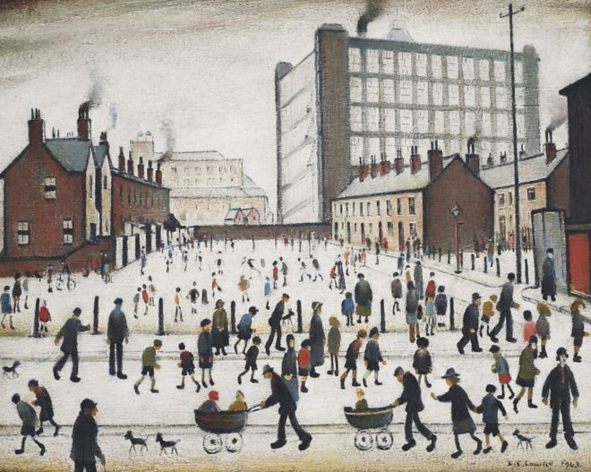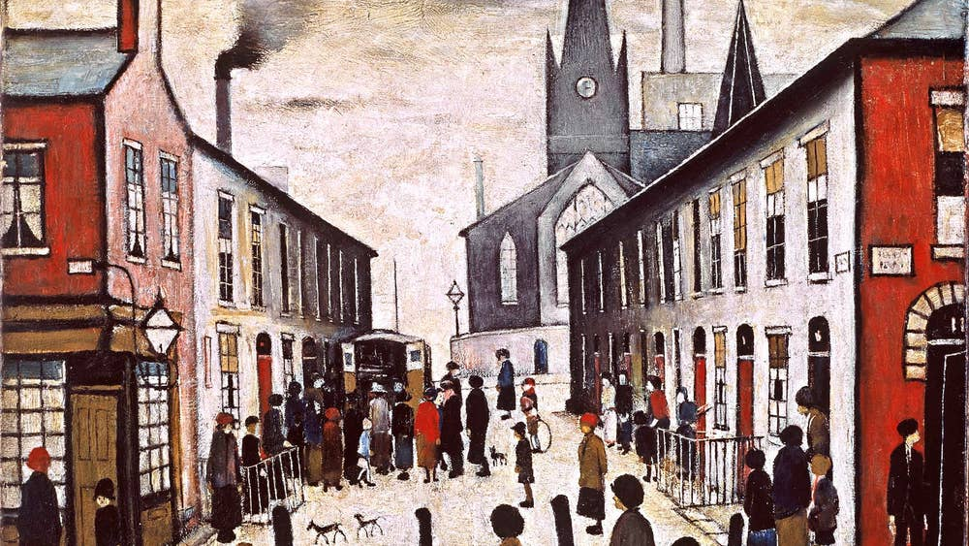

Music:
Listen to Queen’s Bohemian Rhapsody with head phones on.
Can you hear the sound moving from side to side?

History:
How many kings or queens have there been of our country?
Can you put them in order on a timeline?
Who was the most important or interesting do you think? Why?

PE:
Keep doing your core body and vigorous activity exercises daily.
Core body in the morning - vigorous activity at lunchtime.

