Tuesday 10th March 2020
Due in Monday 16th March 2020

Reading Home Learning
(Word Web)

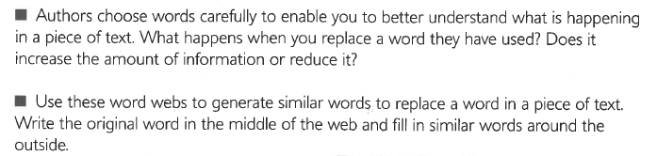

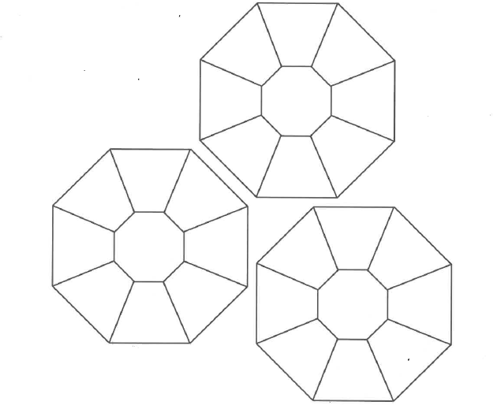

Tuesday 10th March 2020
Due in Monday 16th March 2020

Reading Home Learning
(Word Web – Reading Extract for Horrible Science and Shark Family)

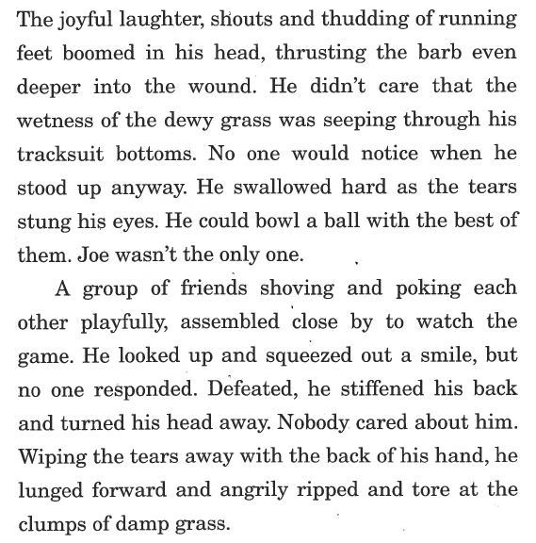

Tuesday 10th March 2020
Due in Monday 16th March 2020

Reading Home Learning
(Word Web – Reading Extract for Black Panther and Mindcraft)

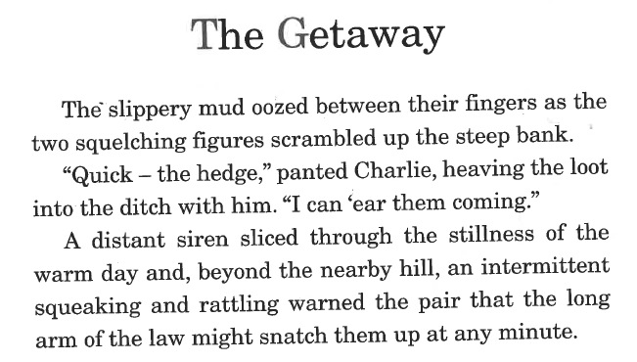

Tuesday 10th March 2020
Due in Monday 16th March 2020

Reading Home Learning
(Word Web – Reading Extract for Where’s Wally)

