Our Maths Tube
17th March 2020

Exploring number bonds to 10 but this time using a 10 frame and just two different categories of items.

I have selected you 10 shells
and a set of 10 trolls!!

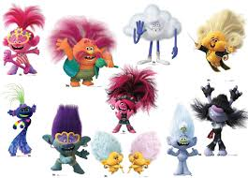
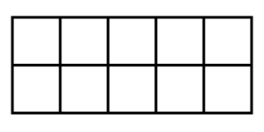
Number bonds to 10
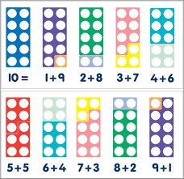

Can you make these different number bonds using your shells and the trolls (You can cut these Trolls out!)

You could also use your own mini characters that you have at home.
Enjoy this number exploration
Miss Butler

