Maths Home Learning
20.11.18 due in 26.11.18.
Number Bond Challenge
Time yourself and see how quickly you can do it.
2 + 4 = | 5 + 0 = | 1 + 9 =
3 + 2 = | 8 + 1 = | 0 + 3 =
4 + 4 = | 6 + 4 = | 4 + 6 =
9 + 0 = | 2 + 5 = | 5 + 5 =
2 + 8 = | 5 + 15 = | 17 + 3 =
7 + 3 = | 2 + 1 = | 10 + 0 =
60 + 40 = | 16 + 4 = | 8 + 2 =
30 + 70 = | 10 + 90 = | 50 + 50 =

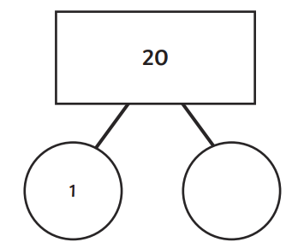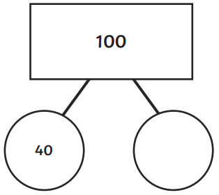
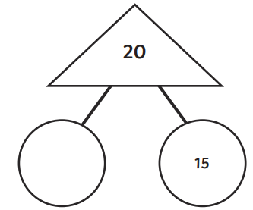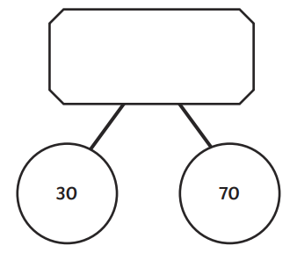

Use these blank number lines to show how you would work out:
5 + 27 = _________
63 + 29 = _________

