Maths Home Learning –Times Tables!
Please complete the times tables grid for this week’s Home Learning. The space below is for you to practice one of the times tables that you find tricky or are not yet fluent with.
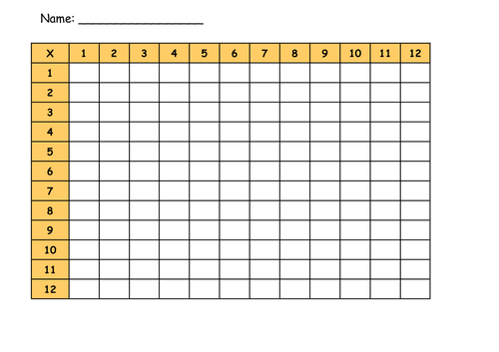
I found my times tables tricky.

