Maths Home Learning - Number Sense
03.03.20 due 09.03.20
Telling the Time: Year 3.
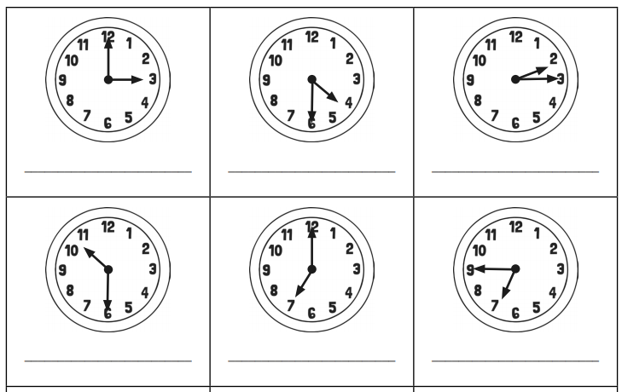
At what time do you usually do the following….
Wake up?

Go to school?

Have your lunch?

Go home from school?

Eat dinner at home?

Usually do your homework?

Go to bed?

