Maths Home Learning – Equivalent Fractions
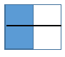
Equivalent fractions are two fraction that equal the same.
e.g. 2/4 are equivalent to 4/8

