Maths Home Learning – Counting and Adjusting Name:_______________________
Wc 13.05.19. Due 20.05.19.
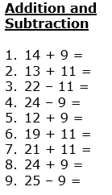
______________________________________________________________
______________________________________________________________
______________________________________________________________
______________________________________________________________
______________________________________________________________
______________________________________________________________
______________________________________________________________
______________________________________________________________
______________________________________________________________

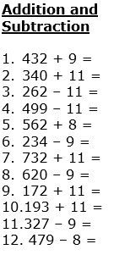
______________________________________________________________
______________________________________________________________
______________________________________________________________
______________________________________________________________
______________________________________________________________
______________________________________________________________
_____________________________________________________________

______________________________________________________________

______________________________________________________________

______________________________________________________________

______________________________________________________________

______________________________________________________________

Show your thinking on the number lines provided.

