Name________________________________
Maths Home Learning
Wc 2.12.19 due 9.12.19
Write a number sentence to describe the times table is shown in the picture below.
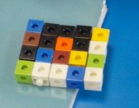

________ X _________ = 20
Or
________ X _________ = 20

Draw arrays to show the following.
Remember when drawing your arrays to keep them in straight lines going both down and across so you can group them easily.
4 X 5 = 6 X 7 =

Share of divide these carrots equally between 3 people, how many does each person get?
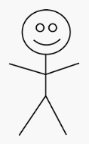

Write a division number sentence to show this in symbols.

____________ ÷ ___________ = ___________

