06.02.18
Due in 19.02.18

Maths Home Learning
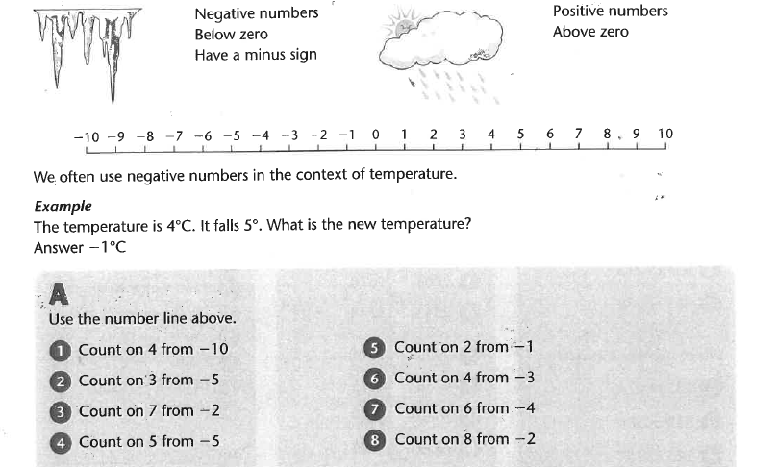
(Negative Numbers)

06.02.18
Due in 19.02.18

Maths Home Learning
(Negative Numbers)
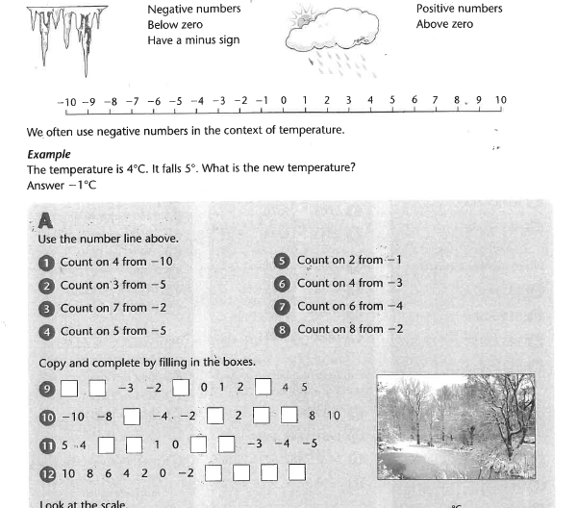

06.02.18
Due in 19.02.18

Maths Home Learning
(Negative Numbers)
