Maths – Rounding Decimals
These activities are ones to discuss with members of your family. The questions are pictures so will not let you edit them on word. The word problems have more than one possible answer, challenge each other to prove their point!

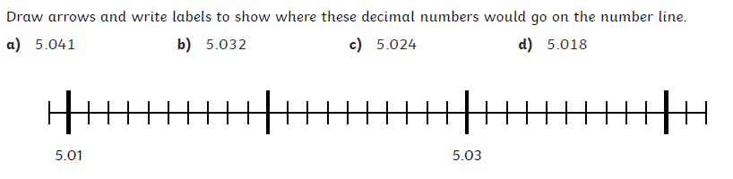

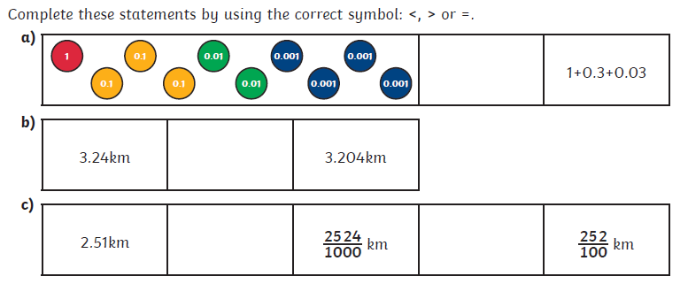

Laura thinks of a number. When she rounds it to the nearest ten, the answer is 27280. What number could Laura have started with? List all the possibilities.

Always, sometimes or never?
• A rounded number is different to the original number
• Two numbers which both round to 370 when rounded to the nearest 10 have a difference of 5 or less
• A rounded number is more likely to be less than the original than more than the original

