17.03.2020
Due in 14.04.2020

Maths Home Learning
(Multiplication and Division - 1)
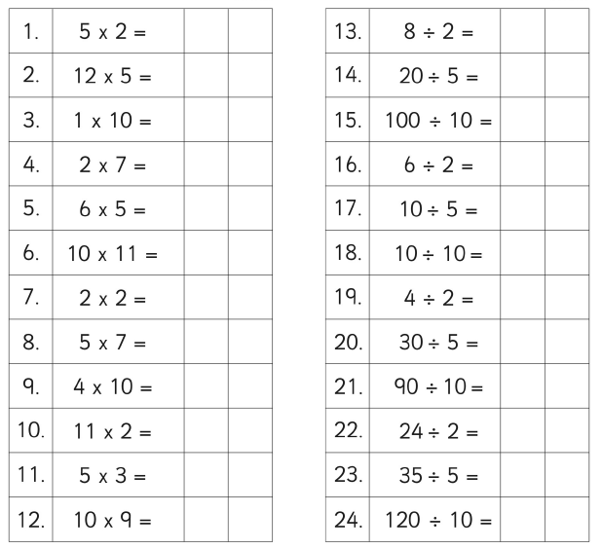

Once you have finished these, use the link below to practise how fluid you are. Some of these will be challenging!
www.timestables.co.uk/multiplication-tables-check/

17.03.2020
Due in 14.04.2020

Maths Home Learning
(Multiplication and Division - 2)

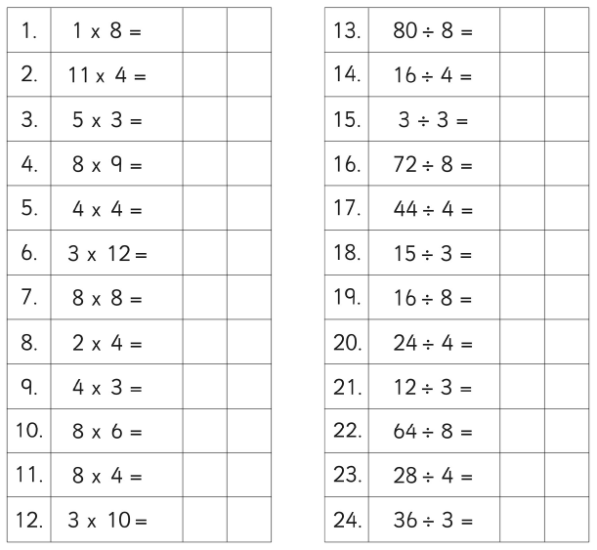

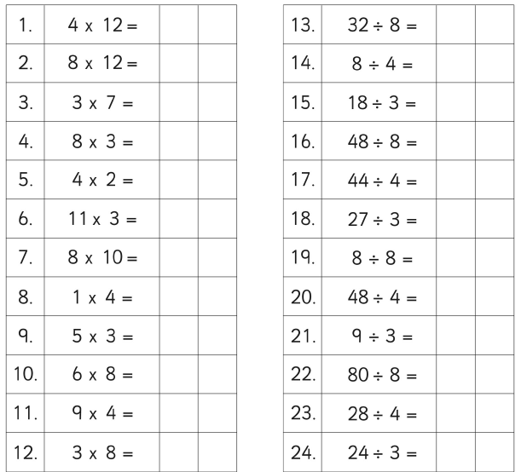

Once you have finished these, use the link below to practise how fluid you are. Some of these will be challenging!
www.timestables.co.uk/multiplication-tables-check/

17.03.2020
Due in 14.04.2020

Maths Home Learning
(Multiplication and Division - 3)
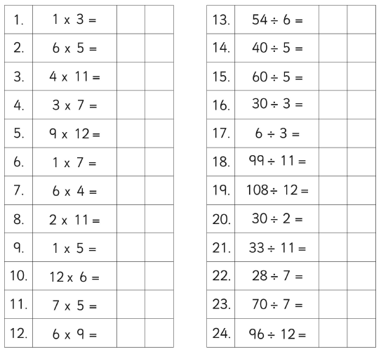

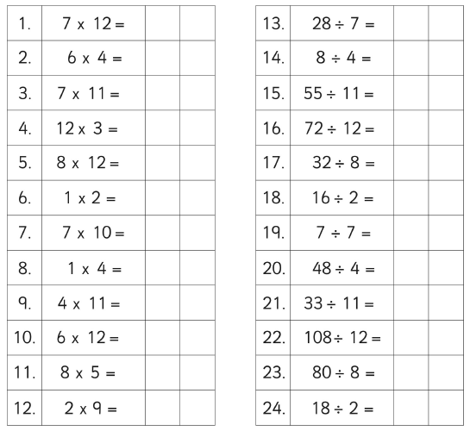
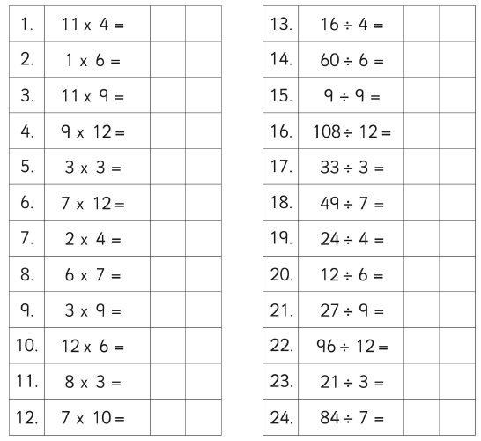
Once you have finished these, use the link below to practise how fluid you are.
www.timestables.co.uk/multiplication-tables-check/

