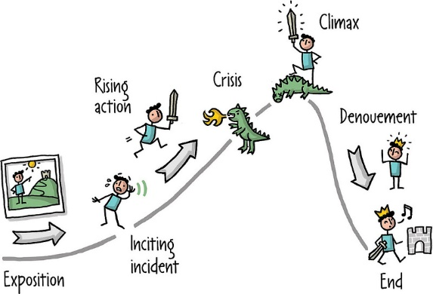
Literacy Home Learning
Please story board a journey that you have been on or go on this week. You could write words or draw pictures along the path to show events/places along the way!

