Literacy Home Learning

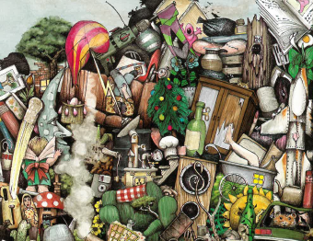
Describe what you can see in the picture above:

