Literacy Home Learning –Fairy Story comprehension
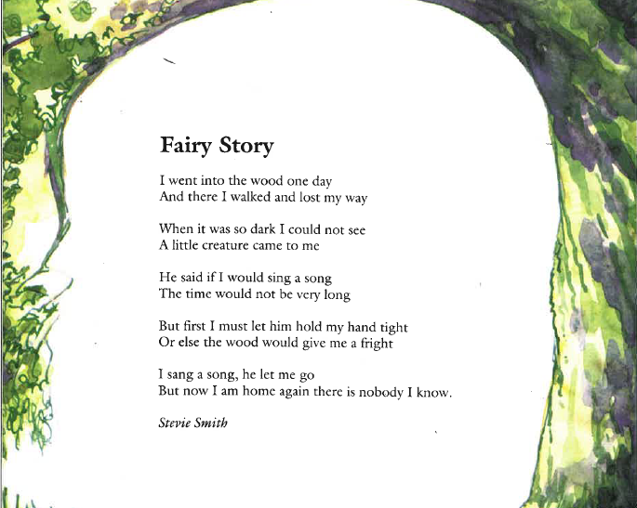

After you have read the story, answer the questions below:
