Home Learning Times Table Tuesday 08.01.19
Due Monday 14.01.19
Year 4
On this 100 Square using three different colours, shade in 7, 9, 11 times tables.
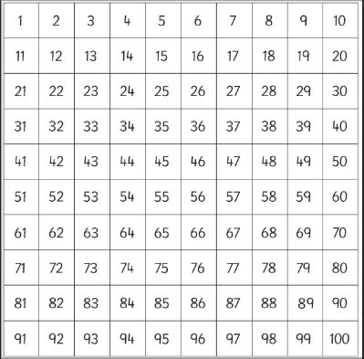

Pick 1 more time table of your choice and see if you can show it on the 100 Square also using a different colour.

