English Home Learning
Wc 18th March 2019
Due 25th March 2019
Expanded Noun Phrases and Adverbials
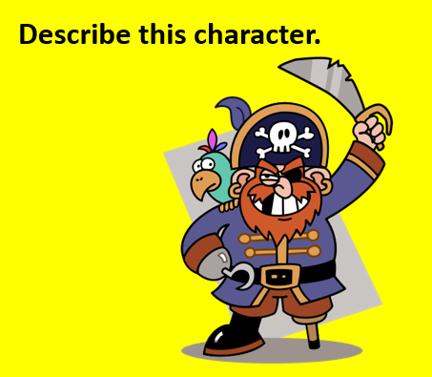
Meet Pirate Woody Foot. He has travelled the seven seas in search of adventure and treasure.
Use your imagination to plan out a voyage for Woody using expanded noun phrases to describe him and adverbials to describe how we has made his journey.
Remember to use a mixture of simple, compound and complex sentences, not forgetting the need to punctuate.
______________________________________________________________________________________________________________________________________________________________________________________________________________________________________________________________________________________________________________________________________________________________________________________________________________________________________________________________________________________________________________________________________________________________________________________________________________________________________________________________________________________________________________________________________________________________________________________________________________________________________________________________________________________________________________________________________________________________________________________________________________________________________________________________________________________________________________________________________________________________________________________________________________________________________________________________________________________________________________________________________________________________________________________________________________________________________________________________________________________________________________________________________________________________________________________________________________________________________________________________________________________________________________________________________________________________________________________________________________________________________________________________________________________________________________________________________________________________________________________________________________________________________________________________________________

